Week 16: Message Center – part 2 – the messages
Last week we did a brief overview of your new main hub of MHS GENESIS – message center. It is your first-stop shop for the most relevant information that you need. But once you get a message…what can you do? A lot! What you do depends highly on the message itself. Sometimes you can delete it (which sounds scary but it only deletes the message from your box). You sign it. You can make a quick note and sign it. But the most robust thing to do is a full message. A full message is akin to an email and has much of the same functionality.
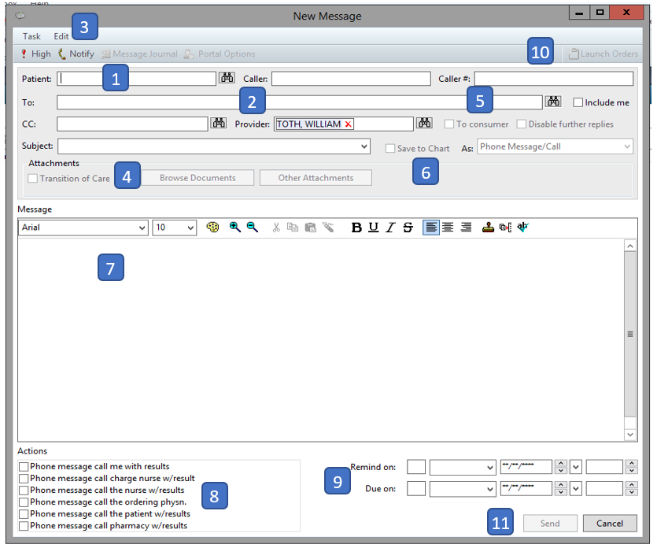
- PATIENT. If you are launching this from a reply option (like from the patient’s chart) then this will be pre-populated. This is not a mandatory field which means you can send messages to others without having a patient attached to the message. I’ve only come up with a couple of use cases to do this, but there is flexibilty built into the system. Caller and Caller # will be populated on a call-in system
- TO, CC, PROVIDER, INCLUDE ME, and SUBJECT. This is much more like email. You can add multiple people, multiple CC’s and a prepopulated or custom subject. Prepopulated messages will fill in the body of the message. You can also decide to include yourself on the message. You may be asking why you would want to do that. Well, reminders. Remember reminders.
- HICH and NOTIFY. Much like email, you can tag messages as high and request a read reciept.
- ATTACHMENTS. “Browse Documents” allows you to see all of the documenation on the patients chart and easily select them for inclusion in the message. “Other Attachments” allows you to search your computer to place additional attachments to the note.
- TO CONSUMER. This is where you mark if you want it to go to the consumer (patient) or not. This can end up being a VERY IMPORTANT CHECKBOX if you accidently send something to a patient meant for a colleague.
- SAVE TO CHART. This is a VERY IMPORTANT CHECKBOX! Not everything belongs in the medical record or is value added. Remember this option.
- THE BODY. This supports autotext and limited customization. The autotext is the most important as in a couple of keystrokes you can have full dialog.
- ACTIONS. Which mark your message for action (duh).
- REMINDERS and DUE ON: I love these functions. We all want our patients to be more engaged. AND we want them to take some degree of responsibilty for their care. These are the buttons that do that. I will include me and send a reminder to the patient of something that we talked about. Especially now that I’m prepping for a PCS it provided me with great power to set up a set of reminders for patients that I thought needed to do something but I was going to be gone.
- In order to place orders you have to have a FIN. And to have a FIN, you have to have an encounter. (that’s an oversimplification, but close enough). But messages aren’t encounters. Enter the between encounter which creates a FIN when you click “Launch Orders”. This isn’t perfect for everything (this isn’t an actual encounter so if you have MDM then you should have an encounter created) but it’s great when you need to create new orders off of a message.
- Send. It’s that easy.
Next Week: Physician Online Ettiquite (how to write a message)
GENESIS 101: Seriously, don’t forget to check (or uncheck?) “to consumer” and “save to chart”. A discussion between colleagues can sound a lot like an argument with a bunch of scary words if you are wrong. Good news though, you can change your default preferences so that it doesn’t automatically end to patients.

