Week 15: Message Center – part 1
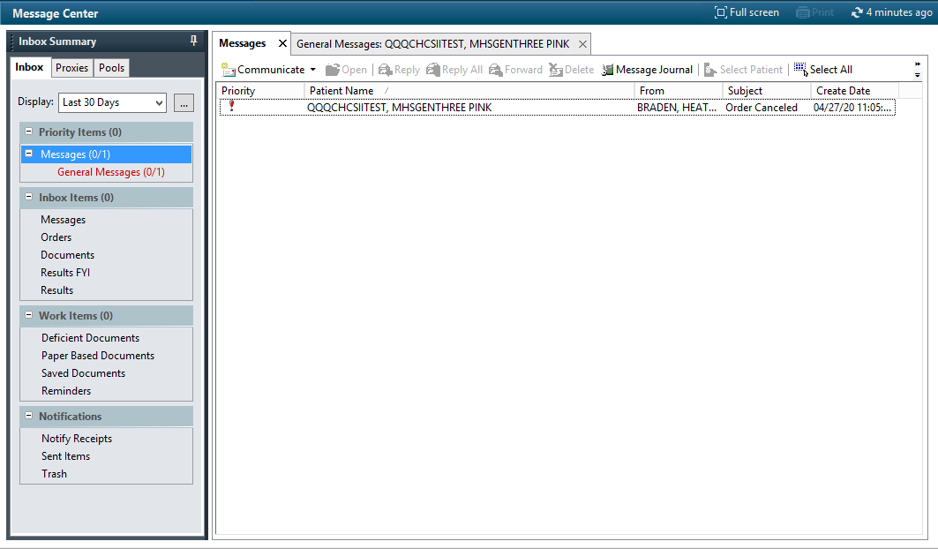
Let’s start out with what Message Center is not. Message Center is NOT simply a secure messaging system to replace Relay Health. Sure, it contains the secure messaging system – which we will show next week - but it is actually the main hub for all communications within the EMR. Between staff. Relating results. With patients. It’s all there. Which is why I love and hate message center. Everything is there…and potentially….EVERYTHING is there. Overall it is a drastic improvement over the multiple offerings that we had in legacy. But get used to message center being your new go-to area. I will also be the first to offer that I am not the expert on message center because I am not routinely part of a clinic I get far less messages than many others. And at the same time I find it fairly easy to navigate.
1
2
3
4
5
- Inbox Summary. This box shows up on most of your initial pages when you enter into MHS GENESIS. For outpatient services it is often shown with your ambulatory organizer (calendar schedule) on the right (where “Messages” are in the screenshot above). For inpatient the “Messages” space contains an abbreviated provider handoff worklist, but the inbox summary remains the same. You can set the display lookback for multiple options or a specific date range. Priority Items are up on the top and it shows you how many of those you have seen (for instance I only have one priority message and have reviewed it). But wait – there’s more!
  - Proxies. Yes. This is what it sounds like. You no longer must go into CHCS and set proxies hoping to remember the codes to make it work. After setting up your proxies you simply click on that box and it will show the inbox for the person that made you a proxy.
  - Pools. Message pools are like an organizational inbox for GENESIS. Instead of sending something to an individual, you can simply send it to a pool of people that can see those messages. Pools have to be set up at the enterprise level, but each clinic (location) should have a standard set of pools to help them organize patient information.
  - Priority Items are exactly what they sound like. Unread and read messages for any critical results show up here.
- Inbox Items. Here is where you see any messages that need adjudication. Messages, Orders, Documents, and Results. We will look a little more in depth at these next week.
- Work Items. Deficient documents, Saved Documents, and Reminders. Reminders is actually one of my favorite features. When seeing a patient or writing a message you have the option of when to have that message delivered (and who it should be delivered to). So if you really need someone to follow up in a certain timeframe, you can simply set a reminder and set it to message the patient and your message pool to make sure someone doesn’t fall through the cracks.
- Notifications is pretty much what it sounds like.
- The Messages Window. Here is where you will see the patient information when you select a patient or result. Once you do that this will fill up with the message and additional options depending on the message/result.

Messages do not have to be placed in the patient’s chart. They are stored, but not necessarily to a patient’s chart unless you decide to do so. This isn’t a replacement for email, but for patient-related inquiries, the ability to communicate between clinical staff can be fantastic. It isn’t my favorite way to relate information for patients I am seeing (it’s not in the workflow for that), but for other quick messages it is another great tool. Not only that, they don’t even need to be attached to a patient. I wouldn’t recommend planning an office party with it, but the flexibility can be pretty incredible.
Next Week: The actual messages.
GENESIS 101: Speaking of reminders – you can actually drop a reminder on a patient within your workflow while seeing a patient. It’s convenient and ensures that you don’t forget what may be the most important part of the visit. “Call me in a week if…” is a thing of the past. Instead I simply set a reminder message for a week to “let me know how xyz is going”.

