

AHLTA Troubleshooting Guide
With
Lessons Learned

Version5.3
27Oct2009

Executive Summary

Thisdocumentiscreatedjointly with DHIMS, TIMPO,and MilitaryBranch Service Technical RepresentativesandSAICtohelpMilitary Treatment Facility (MTFs)troubleshootissues which affect AHLTA.

It is divided into three sections: Slowness,Availability,and Functionality. It is designedin aflowchart styleasking questions which willguidethe user of the documentbyleading them through mostthelikelyroot causeof an issue.The table of contents will allow quick access to specific issues as well.

This document is intended for MTF systems personnel however it can be used by anyone and will provide tips and suggestions on how to correct the most common AHLTA issues.It will enable theMTFto correct issues faster andhopefully reducefrustration when AHLTA issues do arise.

When troubleshooting expands beyond the scope of theMTF,a coordinated effort between the application developers, Program Offices, Military Branch Service Technical Support, MHS Help Desk,the Network Operations Center (NOC), the Defense Information Systems Agency (DISA), and third parties, such as Managed Care Support Contractors (MCSC)will be required.If this is the case,thenthiswillneed to be broughtto the attention of the PerformanceManagement Team(PMT). Pleasecontact your Service Representative to get on thePMTagenda.

This documentalsocontainslessonslearned from theAir Force, Army,and the Navy,as well as,those found during BETAtesting.

This document is intended to be a living document and will be updated frequently. If additionalinformation or inconsistenciesare discovered,please send the information toSAIC(Thomas.E.Britten@SAIC.com) for inclusion in future versions.
Table of Contents

Executive Summary 2
Notice Information 9
Brief description of the Issue 10
1. Is the report for slowness? 11
a.Is it Site wide? 11
b.Is slowness for an Entire Clinic or Satellite? 11
c.Is slowness for a specific EUD or for user? 12
d.Is the slowness for a particular patient? 13
e.Is slowness for Logging into AHLTA? 13
f.Is the slowness for a particular Module? 14
g.Is slowness for a particular Transaction? 15
2. Is this report for going into Local Mode? 16
a.Are you using the Failover.bat File? 16
b.Contact DISA and see if this is a system wide outage or just your Site. 17
c.Is it happening Clinic wide? 17
d.Is Local Mode for a specific EUD or for user? 17
e.Is Local Mode for a particular patient? 18
f.Is Local Mode for a particular Module? 19
g.Is Local mode for a particular Transaction? 19
3. Is this report for Application Busy events? 20
a.Is it happening Site wide? 20
b.Is it happening Clinic wide? 20
c.Is it happening for a few users? 21
d.Is event for a specific workstation or for user? 21
e.Is event for a particular patient? 22
f.Is event for a particular Module? 22
g.Is event for a particular Transaction? 22
4. Is this report for Non-availability? 23
a.Is the Non-availability SSL related (see example above)? 23
b.Is the Non-availability WEB Services related (see example above)? 26
5. Is this report for Functional Difficulties? 29
a.What Version of AHLTA are you using: 838uX or 3.3.x? 29
b.Does the issue have to do with logging in? 29
c.Does the issue have to do with a SQLServr.exe Application Errors (as above)? 30
d.Does the issue have to do with the “ARM” error displayed above during login? 31
e.Does the issue have to do with the “ActiveX” error displayed? 31
f.Does the issue have to do with Error Messages (as seen above?) 32
g.Does the issue have to do with End User Accounts? 32
h.Is the issue with Resident’s ability to Sign Encounters? 33
i.Does the issue have to do with scanning or attaching documents or images? 33
j.Is the issue with attaching documents/images to an Encounter? 34
k.Is the issue with S/O where a User appears to take over the S/O note after the Encounter is transferred to them? 35
l.Is the issue that AHLTA indicates that the user has new, unread items on the Folder Tree? 35
m.Is the issue with not being able to get to the Template Management Module in S/O? 35
n.Is the issue with a template change not being visible to the user after the user had made a change to that template? 35
o.Is the issue with Disposition in that the times for visits cannot be changed from 20 minutes? 36
p.Is the issue where the Provider gets a Dental Disposition when trying to complete an Encounter? 36
q.Is the issue that the user is unable to sign encounter because the Disposition module has “Insufficient Documentation? 36
r.Is the issue when going into the Disposition module the tab and blank screen appear? 36
s.Is the issue when the User tries to Sign the Encounter but needs a Co-signer and the “Cosigner required” box is empty? 37
t.Is the issue when the User opens the Co-Sign Module and there are no Encounters to be co-signed when there should be? 37
u.Is the issue the fact that the Users AIM Forms in their Favorites Folder are no longer useable? 37
v.Is this issue where the user tries to Toggle to CHCS and gets to the Login Screen andthennothing? 37
w.Is the issue with a transferred T-con going to the first Provider on the List? 37
Appendix 39
3.3.x Lessons Learned 40
Preparation: 40
Roles: 41
First time log on to 3.3: 41
Confirm AHLTA installed correctly: 42
Amending Encounters 43
CAC Login 43
CPT Code Impacts (Seen after Midtier load) 44
Clinical notes: 44
Images: 44
Maintenance – Below are recommended actions to maintain over all PC health. 45
Meds/Rads: 46
Miscellaneous: 47
Notifications: 47
Other Errors: 48
Problem List: 49
Previous Encounters: 49
S/O: 49
Spell Check: 50
Tasking 50
T-Cons: 50
Templates: 51
Toggling to CHCS I 52
Tier 1 Errors: 52
Most Common Tier 1 errors 53
How to turn off the ActiveX warning message box from AHLTA Client machines 55
How to turn off the Reminders Pop Window 58
How to Uninstall/Install AHLTA with CTS 66
Ideal Options and Auto-Cite Settings 92
Resources 93
Security Risk Assessment 94

Notice Information |  | Notes:
- Document Date and Time of Notice
- MTF
- Point of Contact
- Confirm the following:
- The CH2CWfolder has at a minimum“Read/Write/Modify”rights foreveryone
- No file in the CH2CW foldershouldhave the“Read Only”attribute selected
- The Datalayer.config fileshould haveeither the FQDN (Port 443 – HTTPS) or the IP Address (Port 80 – HTTP) of the IIS Serverinthe LCS in the WEBServices portion
- If using HTTPS, ensure that thecertificate is valid(you may have to contact DISA to verify this)
- Ensure that the end-usersare correctly mapped to the right clinics andhave the propersecurity roles
- The AHLTA icon (desktop shortcut)should be pointing toeither cw.exe /LOCAL_CACHE (838 Clients) or AHLTA.exe /LOCAL_CACHE (3.3 Clients)
- Some software has been shown to cause issues with AHLTA which prevents it to run. Please check to see if CCE or Hercules have beeninstalledrecently.
  - CCE –delete theExternalApps.configfile found in C:\Program Files\CH2CW\Bin folder
  - Hercules– Ifinstalledafter AHLTA,you will need to remove both apps completely and then reinstallHerculesthenAHLTA

Brief description of the Issue

- Is the report for slowness? | Notes:
  - Is itSitewide?
    - Is the slowness correlated to a specific day?
      - Find out what changes took place on/prior to that day and contactMTFpersonnel to discuss options
    - Is the slowness correlated to a specific time of day?
      - Find out what events are occurring during that time period. (i.e. Virus Scan being run Clinic wide, etc.)
    - Check LCS to see if any processes are hangingoris exhibiting anyabnormal behavior.
      - Ifyes,thencontact DISA to correct.
    - Check AppManager and/or ChariotData (E2E WEBSite) to confirm slowness.
      - If confirmed issue is a Network related problem, contact appropriatepersonnel.
      - If not confirmed, contactMTFpersonnel thathave been trained on the use ofObserverand conducttransactioncapturestoforward toSAICfor analysis.
    - Has the LCS NIC been set to appropriate speed duplex?

Confirm that both the LCS NIC card and the switch it connects toare set to 1000/Full(or on the LCS NIC set to 1000/Full/Auto if available and on the Switch side set to 1000/Full) if GIG is available otherwise set to 100/Full
  - Is slowness for an Entire Clinic or Satellite?
    - If yes,has there been any recent network upgrades?
      - If yes,contactyour MTF networkshop to troubleshoot/correct.
    - Havethere been any recent changes to Clinic/Satelliteconfigurations in CHCSI or AHLTA?
      - Review for completeness accuracy and correct as necessary.
    - If nonetworkchanges, contactyour MTF personnel that have been trained onObserver andconducttransactioncapturestoforward toSAICfor analysis.
  - Is slowness for a specific EUD or for user?
    - Check EUD for multiple running instances of AHLTA, closeother instancesas necessary.
      - Open Task Manager Processes tab and count the instance of cw.exe running (if>1 kill all).
    - Check Memory consumption of AHLTA.
      - Open Task Manager Processes tab and look at physical memory ofcw.exe.If it isabove 512MB or more than 80% of memory,kill the process.
      - Try to replicatethe slowness, take an Observer captureand forward toSAICfor analysis.
    - Check CPU and Memory consumption of otherprocesses.
      - Open task Manager and sort first by CPU then byMemoUsage
      - Ifyou seeany runaway processes,try killing or rebootingthe PCto see if that addresses the problem.If not,contactyour MTF personnel
    - CheckC:\\Program Files\CH2CW\ Folder for Permissions
      - Must be at a minimum“Read/Write/Modify”rights foreveryone
      - If the User tries to Login but it fails due to‘System cannot find the specified file’error message, thencheck the Event Viewer to determine that the Log ‘Tuxedo Proxy’ is logging entries. If there is no ‘Tuxedo Proxy’,then AHLTA was not installed properly and needs to be re-installed. If it is there,then check the entries for any failure messages.
    - Check User Auto-cites/Preferences/Settings to determine if they are set too high/heavy.(See appendix for Auto-cite option settings)
      - If high/heavy, determine if the user needs them set that way.
        - If not needed, make corrections.
        - If needed, explain how they affect user response time.
    - Check EUD for Spyware and Viruses.
    - Check Page File (Should be 1.5 times the amount of RAM)
    - Check Registry size (Set to 128 Mb)
    - Check Size of Application compared to known good.
      - If the size is radically different,then uninstall and reinstall AHLTA and try again.
    - Check Internet Explorer and Microsoft Outlook for slowness.
    - If other apps are affected (depending on yourMTFprocess), you should contact your local network person.
    - Submit local ticket. Make sure to include the following information along with whatever you normally include in a ticket submission:
      - User(s) affected (include User and Provider IEN).
      - IP address/computer name, building and room number.
      - Modules affected.
      - Module timing.
      - Whether or not other apps are affected.
  - Is the slowness for a particular patient?
    - Is the patient a test patient?
      - If yes, try same problem with a non-test patient.
    - If not,please provide the patients name and IEN to SAIC.
  - Is slowness for Logging into AHLTA?
    - Check to make sure that the DNS Lookup is working.
      - From a CMD prompt type nslookup IP address for LCS. After this, type it again using the FQDN (fully qualified domain name).If it does not resolve,then contact your local network Admin to resolve the DNS issue.
    - Does theMTFuse Auto-update?
      - If no, then on the AHLTA Icon, right click and remove the ‘up’ from the CWUP.exe in the Target Location
NOTE: Not applicable to AHLTA version 3.3because3.3 uses AHLTA.exe
    - Check theTime Server Name
      - Open regedit and check the following key: HKEY_LOCAL_MACHINE\SOFTWARE\THINKING MAN SOFTWARE\D4. Verify that the Server/Server string is the FQDN or IP address of the LCS.
    - Check theDatalayer.configand verify that the right configuration is being used in the WEBServices portion.
      - For HTTP the LCS/IIS IP address should be used.
      - For HTTPS the FQDN should be used.
  - Is the slowness for a particular Module?
    - If yes, check UserAuto-cites/Preferences for that module.
      - If high/heavy, find out if user needs them set that way.
(See appendix for Auto-cite option settings)
        - If not needed, make corrections.
        - If needed, explain how they affect User response time.
    - If not high/heavy check similartransactions to determine if it’s slow.
      - Check/Record time for the following modules:
        - Appointments
          - Opening the Appointment Module
          - Create appointment
          - Opening an encounter
        - Telcon
          - Opening the Telcon Module
          - Create a Telcon quick entry.
        - Opening the Allergy Module
        - A/P
          - Opening the Order Entry Tabs
        - Other modules as needed
      - ContactMTF personnel that have been trained on the use of Observerand conduct Transaction Captures toforwardto SAICfor analysis.
  - Is slowness for a particular Transaction?
    - If yes, check UserAuto-cites/Preferences for that Function to see if it is set high/heavy.(See appendix for Auto-cite option settings)
      - If high/heavy find out if user needs them set that way.
        - If not needed, make corrections.
        - If needed, explain how they affect User response time.
      - If not high/heavy,contact MTF personnel that have been trained on the use of Observer and conduct Transaction Captures to forward to SAIC for analysis.

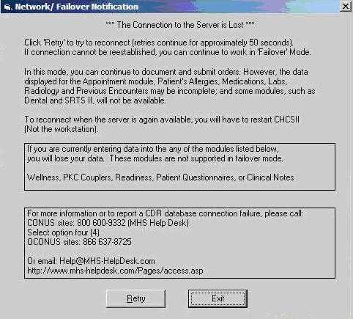

- Is this report for going intoLocalMode? | Notes:
- Are you using theFailover.bat File?
- Use the StopFailOver.bat file.
- Make sure that it is configured correctly.
        - Set up the batch file with Get the first three octets of the IP address and place them into the first three octets of the second address in the route statement.
          - For example: ipconfig returned 111.122.133.005
          - route add 206.38.136.0 mask 255.255.255.0 xxx.yyy.zzz.254 (original)
          - route add 206.38.136.0 mask 255.255.255.0 111.122.133.254(modified)
        - If 254 won't work select 253, 252, etc. You shouldNOTbe able to ping the IP address.
- Contact DISA and see if this is a system wide outage or just yourSite.
- If just yourMTF,check with localnetwork personnel to see if there are any issues with the LAN or COI to DISA.
- When did this start to occur?
- Document any known changes during this time.
- EUD?
- LCS?
- ContactSAICfor PerfMon analysis of LCS.
- Network?
- CheckAppManager and/orChariot Data (E2E WebSite) to determine if there are any network issues.
- Check all devices in the AHLTA Network path to make sure all running properly.
- Is it happening Clinic wide?
- When did this start to occur?
- Document any known changes during this time.
- EUD?
- Network?
- Check all devices in the AHLTA Network path to make sure all running properly.
- IsLocalMode for a specific EUD or for user?
- Does thishappen when the user locks AHLTAwithControl-Z and leaves their workstation for a period of time?
- If yes, please instruct theuser to not use theCtrl-Z function. If this occurs again please let SAIC know.
- Check EUD for multiple running instances of AHLTA, close as necessary.
- Open Task Manager Processes tab and count the instance of cw(up).exe(838) or AHLTA.exe (3.3)running (if>1 kill all).
- Check Memory consumption of AHLTA.
  - Open Task Manager Processes tab and look at physical memory of cw.exe if above 512MB or more than 80% of memory kill the process.
- Check CPU and Memory consumption of otherprocesses.
- Open task Manager and sort first by CPU then by Mem Usage
- If any runaway processes,try killingthe processesor reboot to see if that addresses the problem. If it doesn’t, contact MTF personnel.
- Check UserAuto-cites/Preferences/Settings to determine if they are set too high/heavy.
- If high/heavy, determine if the user needs them set that way.
- If not needed, make corrections.
- If needed, explain how they affect user response time.
- Check work station for Spyware and Viruses.
- Check Page File(Should be 1.5 times the amount of RAM)
- Check Registry size(Set to 128 Mb)
- Check Size of Application compared to known good.
- IsLocalMode for a particular patient?
- Is the patient a test patient?
- If yes, try same problem with a non-test patient.
- Submit local ticket. Make sure to include the following information along with whatever you normally include in a ticket submission:
- User(s) affected (include User and Provider IEN)
- Patient IEN and name.
- IP address/computer name, building and room number.
- IsLocalMode for a particular Module?
- If yes, check UserAuto-cites/Preferences for that module.
- If high/heavy, find out if user needs them set that way.
- If not needed, make corrections.
- If needed, explain how they affect User response time.
- Contact MTF personnel that have been trained on the use of Observerand conduct transaction captures to forward to SAIC for analysis
- IsLocalmode for a particular Transaction?
- Check UserAuto-cites/Preferences for that Function to see if they are high/heavy.
- If high/heavy find out if user needs them set that way.
- If not needed, make corrections.
- If needed, explain how they affect User response time.
- Contact MTF personnel that have been trained on the use of Observerand conduct transaction captures to forward to SAIC for analysis
- Are images being used?
- Submit ManageNow ticket. Make sure to include the following information along with whatever you normally include in a ticket submission:
- User(s) affected (include User and Provider IEN).
- Patient IEN and name.
- IP address/computer name, building and room number.
- Modules affected.

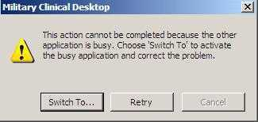
- Is this report for Application Busy events? | Notes:
- Is it happeningSitewide?
- When did this start to occur?
- Document any known changes during this time.
- EUD?
- LCS?
- ContactSAICSE for PerfMon analysis of LCS.
- Has the LCS NIC been set to appropriate speed duplex?
Confirm that both the LCS NIC card and the switch it connects to are set to 1000/Full (or on the LCS NIC set to 1000/Full/Auto if available and on the Switch side set to 1000/Full) if GIG is available otherwise set to 100/Full
- Network?
- CheckAppManager and/or ChariotData (E2E WebSite) to determine if there are any network issues.
- Check all devices in the AHLTA Network path to make sure all running properly.
- Is it happening Clinic wide?
- When did this start to occur?
- Were there any changes to this Clinic at this time?
- Network?
- Check all devices in the AHLTA Network path to make sure all running properly.
- New EUDs?
- Does any Clinic scan documents and images into the Encounter?
- Correlate the scan times to these events.
- Is it happening for a few users?
- Check the EUDs for optimization.
- Make sure the user is not “clicking ahead”.
- Is event for a specific workstation or for user?
- Check EUD for multiple running instances of AHLTA, close as necessary.
- Open Task Manager Processes tab and count the instance of cw(up).exe (838) or AHLTA.exe (3.3) running (if > 1 kill all).
- Check Memory consumption of AHLTA.
- Open Task Manager Processes tab and look at physical memory of cw.exe if above 512MB or more than 80% of memory kill the process
- Check CPU and Memory consumption of other Processes
- If high/heavy, determine if the user needs them set that way.
- If not needed, make corrections.
- If needed, explain how they affect user response time.
- Check work station for Spyware and Viruses.
- Check Page File (Should be 1.5 times the amount of RAM)
- Check Registry size(Set to 128 Mb)
- Check Size of Application compared to known good.
- Is event for a particular patient?
- Is the patient a test patient?
- If yes, try same problem with a non-test patient.
- SubmitRemedyticket. Make sure to include the following information along with whatever you normally include in a ticket submission:
- User(s) affected (include User and Provider IEN).
- Patient IEN and name.
- IP address/computer name, building and room number.
- Is event for a particular Module?
- If yes, check UserAuto-cites/Preferences for that module.
- If high/heavy, find out if user needs them set that way.(See appendix for Auto-cite option settings)
- If not needed, make corrections.
- If needed, explain how they affect User response time.
- Contact MTF personnel that have been trained on the use of Observerand conduct transaction captures to forward to SAIC for analysis
- Is event for a particular Transaction?
- Check UserAuto-cites/Preferences for that Function to see if they are high/heavy.
- If high/heavy find out if user needs them set that way.
- If not needed, make corrections.
- If needed, explain how they affect User response time.
- If not high/heavy,contact MTF personnel that have been trained on the use of Observerand conduct transaction captures to forward to SAIC for analysis(See appendix for Auto-cite option settings)
- Are images being used?
- Submit local ticket. Make sure to include the following information along with whatever you normally include in a ticket submission:
- User(s) affected (include User and Provider IEN).
- Patient IEN and name.
- IP address/computer name, building and room number.
- Modules affected.

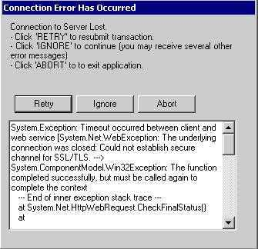
- Is this report for Non-availability? | Notes:
- Is the Non-availability SSL related (see example above)?
- Is it happeningSitewide?
- Is theSiteon using SSL/Port 443?
- If yes, check the “Datalayer.config” file located in C:\Program Files\CH2CW\Bin directory to ensure “https” is in use
- In the Datalayer.config check after the <WebServices> directory under <baseurl>https://XXX.XXX.XXX.XXX/LocalCacheXXX</baseurl>
          - If the “s” is not present add it.
- Also Check the Registry for “https” use.
- Go to “Start\Run” type in “regedit”.
- Go to “HKEY_LOCAL_MACHINE\SOFTWARE\CH2CW\Support
- Lookfor “https” under theWebServices URLdirectory.
            - If the “s” is not present add it.
- CheckAppManager and/or ChariotData (E2E WebSite) to determine if there are any network issues.
- ContactSAICSE for PerfMon analysis of LCS.
- Have DISA check theFIPS Algorithmpolicy in the Registry of the LCS.
- Is it happening Clinic wide?
- When did this start to occur?
- Were there any changes to this Clinic at this time?
- Network?
- Check all devices in the AHLTA Network path to make sure all running properly.
- New EUDs?
- Is it happening for a few users?
- Check the PC for optimization.
- Make sure the user is not “clicking ahead”
- Is event for a specific workstation or for user?
- Check EUD for multiple running instances of AHLTA, close as necessary.
- Open Task Manager Processes tab and count the instance of cw.exe running (if>1 kill all).
- Check Memory consumption of AHLTA.
- Open Task Manager Processes tab and look at physical memory of cw.exe if above 512MB or more than 80% of memory kill the process.
- Check UserAuto-cites/Preferences/Settings to determine if they are set too high/heavy.
- If high/heavy, determine if the user needs them set that way.
- If not needed, make corrections.
- If needed, explain how they affect user response time.
- Check work station for Spyware and Viruses.
- Check Page File (Should be 1.5 times the amount of RAM)
- Check Registry size(Set to 128 Mb)
- Check Size of Application compared to known good.
- Is event for a particular patient?
- Is the patient a test patient?
- If yes, try same problem with a non-test patient.
- Submit local ticket. Make sure to include the following information along with whatever you normally include in a ticket submission:
- User(s) affected (include User and Provider IEN).
- Patient IEN and name.
- IP address/computer name, building and room number.
- Is event for a particular Module?
- If yes, check UserAuto-cites/Preferences for that module.
- If high/heavy, find out if user needs them set that way.(See appendix for Auto-cite option settings)
- If not needed, make corrections.
- If needed, explain how they affect User response time.
- Contact MTF personnel that have been trained on the use of Observerand conduct transaction captures to forward to SAIC for analysis
- Is event for a particular Transaction?
- Check UserAuto-cites/Preferences for that Function to see if they are high/heavy.(See appendix for Auto-cite option settings)
- If high/heavy find out if user needs them set that way.(See appendix for Auto-cite option settings)
- If not needed, make corrections.
- If needed, explain how they affect User response time.
- If not high/heavy,contact MTF personnel that have been trained on the use of Observer and conduct Transaction Captures to forward to SAIC for analysis.(See appendix for Auto-cite option settings)

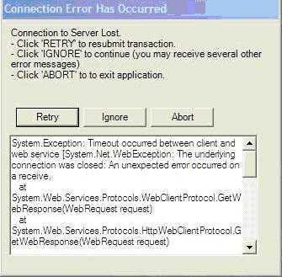
 | - Is the Non-availability WEB Services related (see example above)?
 | - Is it happeningSitewide?
 | - Ping the LCS to see if you can reach it, if not investigate the Local Area
 | - When did this start to occur?
 | - Document any known changes during this time.
 | - EUD?
 | - LCS?
 | - Network?
 | - CheckAppManager and/or ChariotData (E2E WebSite) to determine if there are any network issues.
 | - ContactSAICSE for PerfMon analysis of LCS.
 | - Is it happening Clinic wide?
 | - Is it happening Clinic wide?
 | - When did this start to occur?
 | - Were there any changes to this Clinic at this time?
 | - Local Area Network?
 | - Check all devices in the AHLTA Network path to make sure all running properly.
 | - New EUDs?
 | - Is it happening for a few users?
 | - Is it happening for a few users?
 | - Check the PC for optimization
 | - Is event for a specific workstation or for user?
 | - Check UserAuto-cites/Preferences/Settings to determine if they are set too high/heavy.
 | - If high/heavy, determine if the user needs them set that way.
 | - If not needed, make corrections.
 | - If needed, explain how they affect user response time.
 | - Check work station for Spyware and Viruses.
 | - Check Page File (should be 1.5 times the amount of RAM)
 | - Check Registry size(Set to 128 Mb)
 | - Check Size of Application compared to known good.
 | - Is event for a particular patient?
 | - Is the patient a test patient?
 | - If yes, try same problem with a non-test patient.
 | - Submit local ticket. Make sure to include the following information along with whatever you normally include in a ticket submission:
 | - User(s) affected (include User and Provider IEN)
 | - Patient IEN and name.
 | - IP address/computer name, building and room number.
 | - Is event for a particular Module?
 | - If yes, check UserAuto-cites/Preferences for that module.
 | - If high/heavy, find out if user needs them set that way.(See appendix for Auto-cite option settings)
 | - If not needed, make corrections.
 | - If needed, explain how they affect User response time.
 | - Contact MTF personnel that have been trained on the use of Observer and conduct Transaction Captures to forward to SAIC for analysis
 | - Is event for a particular Transaction?
 | - Check UserAuto-cites/Preferences for that Function to see if they are high/heavy.
 | - If high/heavy find out if user needs them set that way.(See appendix for Auto-cite option settings)
 | - If not needed, make corrections.
 | - If needed, explain how they affect User response time.
 | - If not high/heavy,contact MTF personnel that have been trained on the use of Observer and conduct Transaction Captures to forward to SAIC for analysis(See appendix for Auto-cite option settings)
- Is this report for Functional Difficulties? |  | Notes:
- What Version of AHLTA are you using: 838uX or 3.3.x?
- If you are using 3.3 are you on the latest version?
- Latest is 3.3.3.2 Client Patch8.0
- If you have any other version of 3.3.3.2please upgrade to CP 6.0 (files are currently onDADs) and confirm issues are stillnotoccurring
Note: If you have 3.3.3.1, then install Client Patch 3.0 prior to CP8.0
- Does the issue have to do with logging in?
- Ensure the Datalayer.config has the correct name for the LCS in the<WEBServices><baseurl>parameters:
- The FQDN must be used forSites using “HTTPS”
- The IP Address must be used forSites using “HTTP”
- Ensure the Ahlta.Exe.config file has the correct name for the LCS in the <Service Connection> <SecurityServer> parameter
- With 3.3.x the registry is not used other than for the installs: These file are located in C:\Program Files\CH2CW\Bin folder
- Has CCE been loaded recently on the EUD?
- If so please delete theExternalApps.configfile found in C:\Program Files\CH2CW\Binfolder
- Has Hercules recently been loaded on the EUD?
- Both applications will need to be thoroughly removed. Load Hercules first then AHLTA

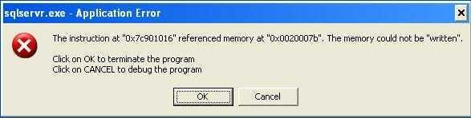

- Does the issue have to do withaSQLServr.exe Application Errors (as above)?
- Has the EUD ever had the AHLTA Training System (CTS) loaded?
- If it is not currently loaded please run a registry cleaner to help resolve the issue
- AT several NavySiteit was found to be caused by NAVFIT 98 which is installed on the EUD prior to the install of AHLTA 3.3.x it would generate this error. To fix uninstall and re-install NAVFIT 98.
- As a precaution to prevent this error CampPendletonhas removed NAVFIT 98 from its Image and only installs as needed

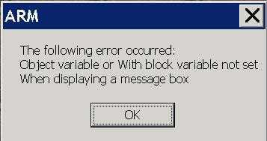

- Does the issue have to do with the “ARM”error displayed above during login?
- The problem is that AHTLA is attempting to setup communications to the PC’s serial communications port
To resolve this problem the communication setup section of theAhlta.Exe.config(located in the C:\Program Files\CH2CW\Bin directory) file must be turned off. This is accomplished by changing the “Y” to “N” reference the example below.
<CommPort>
<BaudRate>9600</BaudRate>
<On>N</On>
<Port>1</Port>
<DataBits>8</DataBits>
<Parity>N</Parity>
<StopBits>1</StopBits>
</CommPort>
- Does the issue have to do with the “ActiveX” error displayed?
- See theActiveXfix in the Appendix.

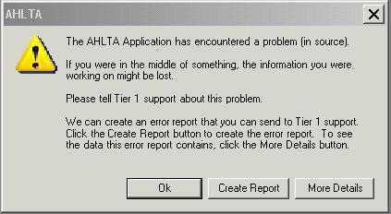

- Does the issue have to do with Error Messages (as seen above?)
- With 3.3.x a generic Error Message Box(Tier 1) pops up indicating AHLTA has encountered an error (In 838 this pop box stated “VB Error”)
- With 3.3.3.2 CP 6.0 when the message box pops up it automatically generates a text file in the users Temp File with the details of the error message
- Location is “C:\Documents and Settings\<user>\Local Settings\Temp” folder
- The format of the file name is “ahlta_err_details_mmddyyyyhhmmss.txt.”
- Does the issue have to do with End User Accounts?
- For new 3.3.xSites has the SnareWorks conversion script been completed?
- Ifnot please contact DISA to have them complete
- Retest oncecomplete

- Is the issue with Resident’s ability to Sign Encounters?
- Confirm that the conversion script has been run for theSite
- Non-Providers should assign a Supervisory Provider to the Encounter during the signing process
- If neither of the above apply theSiteshould look into the "SupervisingRequired” Flagin CHCSI for the Residents. Setting the role in CHCS to "N" and advising Residents to set theirAHLTAencounter summary (options) default cosigner should allow the resident to sign encounters without having to add his or her supervising provider to the encounter as an additional provider
Note: This should beapprovedby the Hospital Commander
- This will also apply to nurses, technicians, case managers, dieticians, etc. who complete their own notes or perform Non-Provider Order Entry.
Note: This should beapprovedby the Hospital Commander
- Does the issue have to do with scanning or attaching documents or images?
- Is the issue with viewing Encounters after the document/image attached to the Encounter?
- Are you using 838?
- If so there is an issue in that the size of the attached document/image prevents the Encounter from opening
- Create aRemedyticket and send to Tier3 to have the Encounters sent directly to you.
- This also applies to the Previous Encounters Module
- This is not an issue with 3.3.x

- Is the issue with attaching documents/images to an Encounter?
- Are you using 3.3.x?
- 3.3.x was redesigned to prevent Encounters from not being able to open after attaching large or multiple document/image
- Users will see a message box pop upindicatingthat they could not attach the document/image due to being over 512kb or they have attempted to attach more than ten items to an Encounter
- 838 does not have this message
- In mixed environments (838/3.3.x users) there is an issue where the COTS image viewer version in the current release is not backwards compatible, images that are included in the Add Note section of encounters created, amended or appended in the current release do not display when the encounter is viewed in a previous AHLTA release
- The same holds true for images included in the patient’s Clinical Notes module. Images in the Add Note section of the Current Encounter summary and the Clinical Notes module display associated text and an empty rectangle when opened in a previous AHLTA release
- Images inserted in the patient’s Clinical Notes module or the Add Note section of encounters created with a previous AHLTA release display normally in the current release

- Is the issue with S/O where a User appears to take over the S/O note after the Encounter is transferred to them?
- With the 3.3.x this functionality was targeted for a performance improvement in that if there is not a current S/O Note for the Patient then the window asking to create one no longer pops up.
- Is the issue that AHLTA indicates that the user has new, unread items on the Folder Tree?
- With 3.3.x AHLTA was designed to display new items for a particular module on the Folder tree, this function currently does not work and AHLTA may display a number even though it is not correct
- Train Users to periodically open these module to view/modify the contents
- Is the issue with not being able to get to the Template Management Module in S/O?
- Have the user load a AIM Form, this will allow the Template Management short cut to appear
- Is the issue with a template change not being visible to the user after the user had made a change to that template?
- Have the user log out and back into AHLTA: this should refresh the Users Templates

- Is the issue with Disposition in that the times for visits cannot be changed from 20 minutes?
- 20 minutes is the default unless the providers changes the >50% time spent counseling
However, this only appropriate for coding purposes when the E&M level needs to be increased due the provider spending more than 50% of his or her time counseling or coordinating the patient’s care; Example: It is not appropriate for coding purposes when doing a Well-woman appointment which is clearly >20 minutes but not >50% of that visit is spent on counseling. Counseling is part of that Well-woman appointment.
- According to the coding rules time is not a dominant factor for assigning the appropriate E&M code in most scenarios. AHLTA 3.3 is working as designed and corrects the issues in 838. Please see the Appendix section3.1.5. Encounter Durationfor further details.
- Is the issue where the Provider gets a Dental Disposition when trying to complete an Encounter?
- The issue is caused by a user with a Dental Role: to clear this you will have to create a new Encounter and transform the data from the old encounter to the new encounter and then Admin Close the old encounter.
- Is the issue that the user is unable to sign encounter because the Disposition module has “Insufficient Documentation?
- This is corrected with 3.3.3.2 Client Patch 6.0
- If running any prior 3.3.x version the workaround is to change the Workload to “No” and then back to “Yes”
- Is the issue when going into the Disposition module the tab and blank screen appear?
- This is corrected with 3.3.3.2 Client Patch 6.0
- If running any prior 3.3.x version the workaround is to close the module and try to open it up again
- If the module doesn’t close, go to the Appointments module and select another appointment
- This will force the current encounter to close: select the patient again, open the encounter and complete it.
- Is the issue when the User tries to Sign the Encounter but needs a Co-signer and the “Cosigner required” box is empty?
- Workaround – Right-Click in the empty “Cosigner required” box and select “Restore Defaults.”
- Is the issue when the User opens the Co-Sign Module and there are no Encounters to be co-signed when there should be?
- If this is the case, when in the co-sign module, have the user right-click in the co-signature box and select 'Restore Column Order Defaults' from the drop down list.
- Is the issue the fact that the Users AIM Forms in their Favorites Folder are no longer useable?
- The issue could be that they had saved an Enterprise AIM Form to their Favorites instead of linking to it
- Saving them as personal forms tends to make them corrupt
- With 3.3, you can link an Enterprise level AIM Form to your template and then add any specific terms you like
- With the link, the User will retain the original AIM form and receive any updates to the Form automatically
- This is especially true of the ‘Usability’ AIM form. Need to verify that linking is working correctly.
- Is this issuewhere the user tries to Toggle to CHCS and gets to the Login Screen andthennothing?
- Is the user on 3.3.3.2and Reflections?The issue has to do with users double clicking the CHCSI toggle button. When the user clicks the Toggle button there is a ten to 15 second delay which causes the user to click the toggle button again.If so please delete theWRAMIBfile then instruct the users to only click once.
- Is the issuewith a transferred T-congoingto the first Provideron the List?
- This occurs when the Assigned Order drop-down is blank on the Telcon Entrytab;please make sure that the correct Provide is selected.

Appendix

3.3.x Lessons Learned
Emphasize to the user the importance of restarting the workstation daily. It improves the health of the workstation and AHLTA operations

Preparation:
- Inadditionto training,it is recommended thatclinicians sign all notes in 838 prior to the upgrade.
      - Mostencounter notesstarted in 838 willsuccessfully completein 3.3 butsome may not,so it is recommended tokeep at least one 838 EUD available.
- AHLTA 3.3.3.2 does not use the same configuration toolsor files as it has in the past
        - Configuration changes are made in:
          - AHLTA.config.exe
          - Datalayer.config
- AHLTA 3.3.3.2 uses Microsoft Internet Explorer objects andifthe MTF has IE security set to the highest level,thePC IE security must have the LCS FQDN listed as a trustedSite.
- MTF’s continue to use a common logon for the EUD, but have multiple AHLTA windows open on the EUD at the same time, based on the number of users accessingthe PC
        - Normally it has been between 2-4 different AHLTA users
        - Make sure there is adequate RAM to handle this (recommend 4 GBs)
- To improve performance, PC performance options should be setto Adjust for best performance
        - Right Click My Computer and go to Properties
        - Click on the Advanced tab then click on the Performance Settings button
        - Select “Adjust for best performance”
- If AHLTA 3.3.3.2 clinical training system is deployed, all versions of SQL must be removed from the PC, prior to the installation of AHLTA clinical training.
- Prior to the deployment of client AHTLA 3.3.3.2 please make sure that SAIC or the CHCS I system administrator has run the AHLTA Security Matrix Scripts.
- All Users must have Multi Sign Enabled in CHCSI for AHLTA 3.3 users to work properly
- Prior to any AHLTA 3.3.3.2 deployment:
        - LCS Garbage Collection should have already been implemented, but this needs to be verified

Return to the Table of Contents

Roles:

- Systems administrators will benefit by making role adjustments in advance. Plan for some users to need additional roles as each clinic goes live.
- Keep the altered roles in mind when troubleshootingwhy a user cannot do something

First time log on to 3.3:

- Users must choose their workstation location upon logging in. They will only have their MTF and assigned clinics available (no long list). You may want to specify that they must choose the MTF. Since it now only lists their respective MTF, many users just cancel this screen since ‘OK’ is grayed out. They must highlight the MTF then choose their primary clinic. As with 838, if this is not set,errors may occur particularly when ordering.
- Signature blocks need to be re-set.
- Viewing options may also change for some users. In some instances the Shortcuts menu will be available but not Folders on initial loading. For some users this is a showstopper.
- User should become familiar using Auto-Hide with the “Folders List” and “Reminders” panes.
- The Auto-Save box should not be checked.

Return to the Table of Contents

Confirm AHLTA installed correctly:
- With the release of CP 6.0 functionality was added to the A/P Order Entry Modules to indicate the status of the CHCSI connection. There have been multipleMTFsreporting multiple issues with A/Pmoduleafter loading CP 6.0 or greater. Sometimes a Tier 1 error is thrown on opening with a location of “A/P.ProxyOE.InitCDROE” If this is the case,you will need to uninstall/reinstall AHLTA (seeHow to Uninstall/Install AHLTA with CTS)
- If there is no Tier 1 error,the best way to confirm a good install (95%) of the time is to confirm that you have 3.3.3.2 and Cp 6.0 (7 or8) loaded via“Help About”and confirm that on the Order Entry Consult tab has CHCS Connection: shownbelow

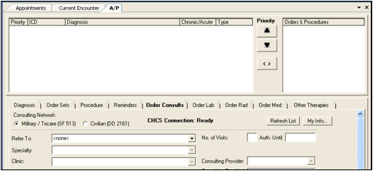

Return to the Table of Contents

Amending Encounters

- In AHLTA 3.3, if a provider cannot sign an encounter after amending it from previous encounters and it remains in a state of updating,your AHLTA Support team will need to be contacted before that encounter can be signed again.
        - DHIMSOfficial Guidance: Avoid amending encounters from a previous day. It is ok to make an addendum(same as “append”). If support staff must enter an encounter to enter their documentation, it is advisable to wait until the end of the day or until the nurse has finished to sign the note.

CAC Login
- Use of the CAC card is not officially support with 3.3.3.2 up to version Client Patch 8.0. However it has been found that users have used their CAC to access AHLTA which can lead to numerous errors. It is recommended that the following be done to prevent the CAC login screen from appearing when logging in to AHLTA:
        - Create a notepad document with no content and name it CACCardMonitor.exe
        - In the C:\Program Files\CH2CW\Bin, rename the existing file to CACCardMonitor.exe.OLD
        - Place the text document from step one in the folder
        - On next AHLTA login the screen will appear as below

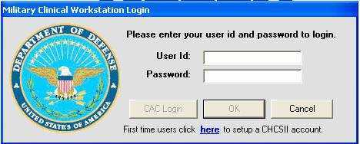

Return to the Table of Contents

CPT Code Impacts (Seen after Midtier load)
- 2008 CPT Codes – (Refer to “CPT FY2008 Informational_11Mar08” – located on Field Services under Hot Docs and AHLTA 3.3 page)
  - Normally the invalid code set is loaded on the AHLTA LCS with the ICD patches. This time the new E&M selection table was added as well (does not include the new CPT code set). This means users on 838p21 workstations can see the new E&M codes. Since these are not yet in CHCS this will cause write back issues. This follows the recommended AHLTA before CHCS loading scenario with resolution discussed further in the referred to informational.
  - Also additionally Nurses will only see the E&M code 99499 for T-cons regardless of the workload status. They should be able to enter appropriate Procedure codes designated for nurse telephone consults. Physician providers should also be able to see 99441-99444 and 99499 for Telephone consults.

Clinical notes:
- Clinical notes can now be printed directly from the module
- Cannot view images saved in 3.3 on an 838 machine
- The POC Facility field may disappear after editing a clinical note
- Cannot change the date of the Clinic Notes

Images:

- Plan the 3.3 deployment keeping this in mind. If your ER scans in the ETRs, they are best placed at the end of the deployment schedule. Otherwise, these notes will not be visible to those running 838.
- In AHLTA version 838, there was a known issue with adding images or scanned documents to AHLTA. This resulted in errors when signing, being unable to find these records in previous encounters, or being unable to view them. This problem has been fixed in AHLTA version 3.3 thanks to images being automatically compressed when entered.
- In AHLTA 838, if too many scanned document pages or JPEG images have been placed into the Add Note section, you will be able to sign the note (with errors), but then they will not show up in Previous Encounters.
- To correct this, find the encounter in question by going to the day of the appointment on the appointment list. Double click to open the Encounter. Find the original signer of the ‘Add Note’ section that contains the images and have that user reopen the Add Note (select edit) allowing the user to use BACKSPACE to delete the images. Deleting the Add Note Section is not an option because it keeps the image attached to the encounter at the bottom in Change History.
        - DHIMS Official Recommendation: If using AHLTA 838, limit the number of scanned documents/attached images to about two, or use a computer with AHLTA 3.3 installed.

Return to the Table of Contents

Maintenance– Below are recommended actions to maintain over all PC health.
- General (initial:)
        - Allow the end user to shut down or restart their PC without hitting the power button
        - Remove old profiles (users no longer atMTF) or profiles that have not been in use for 30 or more days
        - Defrag
        - Clear out temp directories
        - Clear out internet temp files and cookies
        - Scan disk for any errors
        - Remove unused/old programs
        - Run a registry cleaner

- Daily:
        - Clear out .tmp and .ini files daily (from user profiles temp and c:\temp directories)Note: This will beautomaticwith 3.3.3.2 SP1
NOTE: Do not remove any “ahlta_errors_details[].txt” files! These are theTier1 error messages and are required to analyze issues at your Site
          - There are several ways to automate thisPlease use each at your discretion. Please test first before pushing out.
            - Bat file:
@echo off
del"c:\Documents and Settings\%username%\Local Settings\Temp\*.ini"
del"c:\Documents and Settings\%username%\Local Settings\Temp\*.tmp"
            - SMS:
@echo on
cd /D C:\Documents and Settings
for /D %%a in (*.*) do DEL /F /Q "%%a\Local Settings\Temp\*.ini*"
for /D %%a in (*.*) do DEL /F /Q "%%a\Local Settings\Temp\*.tmp*"
for /D %%a in (*.*) do FOR /D %%b IN ("%%a\Local Settings\Temp\*.*") DO RMDIR
/S /Q "%%b"
Exit
        - Re-boot the PC
        - Empty your Recycle bin

- Weekly:
        - Clean out files from your temporary files directory
        - Delete your temporary Internet files & clear your Internet history
        - Delete your cookies

- Monthly:
        - Defrag monthly
        - Run "ScanDisk" to check hard drive for errors
        - Run "Disk Cleanup" to delete unneeded files
        - Back up your files and store them away from your computer
        - Check for the latest Service Packs/Updates for Windows, Office, Internet Explorer
        - Check for unneeded or unused programs and consider uninstalling them
        - Check and clean your registry from errors
        - Remove old profiles (users no longer at Site) or profiles that have not been in use for 30 or more days

Meds/Rads:
- All locations are now listed and former default options are not available.

Return to the Table of Contents

Miscellaneous:

- In 838 when adding multiple procedures in the A/P module if you added a provider in one of the procedures, it would automatically add the provider into the other listed procedures. Now they have to open each procedure and check the box, add the provider, and role.
- The Results and Cosigns modules were slow to open when first updated to 3.3, but that was due to old results and old encounters needing co-signature that appeared in those modules. Once the old results and cosigns were removed, performance increased. The Notification module should be checked too. Sometimes updating to 3.3 pulls old notifications into the Notification module. Clearing the old notifications will increase performance.
- Clicking multiple times on a folder will cancel out the action initiated. This is a training issue at this time until otherwise redesigned. Click only once per folder. Once a folder is clicked you must click somewhere else in the folder list and then go back and click the original folder again to make it work for a second time.
- Other systems: Internet Explorer7 works with 3.3.3.2! The ATS can be loadedforproduction on any PC. See appendix for detailed steps to loading 3.3.3.2.
- In the Demographics module when clicking the “Prim. Care Mgr” button the Primary Care Information window is blank. In 838 this informationmay have beenpresent. This is expected at the moment because to correct this problem requires a long term fix. It will not be corrected until Release Version 3.3u4 when the eGate is updated.
- Loading ofhot fixesor single dlls make sure that the Read Only attribute is not set

Notifications:

- The folder list does not show the number of alerts for all modules. Ensure users know to check ‘Sign Orders’ to take action as they may not see a notification.
- ‘Notifications’ will occasionally indicate there are notifications but the module is empty when loaded.

Return to the Table of Contents

Other Errors:

- AHLTA self healing – At times AHTLA will attempt to reload itself.This is a function of the Microsoft Installer program When a user attempts to login into AHLTA there is a checksum that determines if the appropriate files are still the same as when installed. If not the Install program will attempt to repair itself which typically means that the default config files are used. When this happens the user cannot log into AHLTA. While restoring the config files usually works to correct this problem it is recommend that AHLTA be reinstalled since the amount of restored files is unknown so other issues may arise.
- The Army uses an application calledCredantfor “data at rest”. When this is set at “high priority” it cases problems withAHLTA, and/or Dragon.
- FIPS causes issues with AHLTA. If FIPS is turned on,users may not be able to log into AHLTA. An error occurs during the login process which states “Object reference not set to an instance of an object” and then the login process stops. If this occurs,locate and rename/delete the file “ExternalApps.config” located in C:\Program Files\CH2CW\Bin\ExternalApps.config.

FIPS also conflictswith Credant. Wireless devices use FIPS compliance standard encryptionsowhenloading or updating AHLTA onwirelesstablets,the wireless radio must be turned off.
- NTUSER Hive – Errors have been created after the fact when a user logs off, but Microsoft operating system does not release the user profile and is hung in the register. User can login and since the hive was not released old data is availablewhich could cause issues with AHLTA such as having patient data showing up in anotherpatient’srecords or errors on login.
  - This is a know issue within Microsoft and can be resolved by adding the ProfileClean Service, available at the following URL:
    - URL: http://www.microsoft.com/downloads/details.aspx?FamilyId=1B286E6D-8912-4E18-B570-42470E2F3582&displaylang=en
- Printing
        - Clinical Notes –If only PHI data printsrecommend cutting and pasting data from the Note to Word (or similar) and then print
        - Multiple Encounters – When printing multiple Encounters only the header data will print on subsequent Encounters. Recommend only printing one Encounter at a time
- Port 8080 - MEDCIN using port 8080 127.0.0.1. Credant and other applications uses port 8080, if your MTF is using 127.0.0.1 port 8080,this will lead to different errors and will be sporadic.

Return to the Table of Contents

Problem List:
- Associated encounters may not populate the problem list. The issue of the problem itself not populating the list in 838 seems resolved.
- Encountercomments associated to a problem in the A/P module and marked for inclusion in the master problem list are not populating Problem List.

Previous Encounters:
- Defaultdisplay is last 20. There is no way to change this but you can type another number in the “View Last,” click enter and narrow yoursearchfor that instance(fixed in a future release.)

S/O:
- Tildes (~) incorporated in the free text of templates to facilitate spacing of the note may be duplicated when loaded in 3.3. If this occurs, it will not space correctly and there will be extra tildes in the note. Eliminate any tildes in the templates (AHLTA templates or Word templates that are being pasted in).
- Ctrl+Enter works to enter a carriage return in the free text.
- While free texting, every time Auto-Save saves, it will work as an ‘enter’ which may cause issues for the user when typing such as cursor disappearing to Notes typed during this period not being added to users being kicked out of the free text box. It is recommend turning off the auto-save feature by deselecting this via the Options dialog box on the Encounter Note..
- 3.3 now allows multiple instances of a term with different family or history of prefixes. To add a term as family history in 838, you clicked plus then assigned the prefix. The result was one term with the FAM HX prefix. To add FAM HX in 3.3, select the term (do not click plus), then assign the FAM HX prefix. If the term is selected as positive first, then the prefix is assigned, the result is two terms added: one as personal HX and one as FAM HX.

Return to the Table of Contents

Spell Check:
- Spell check wasturned off with Client Patch 6.0because it caused errors. Itwill be made available withversionSP.1.
- Note that spell check works in the search screens as well as free text fields and will offer suggestions when right-clicked.
- Auto-correct can be leveraged to speed documentation (i.e.: ‘plan’ can be typed and autocorrect set to replace the word ‘plan’ with any pre-set text such as ‘Treatment plan: no PT for 48 hours, alternate hot and cold packs…’).
- Many medical terms and acronyms are not recognized. The auto-correct of these items may result in users wishing to disable this function.
- Thecustomdictionaryfor a user islocated on the local PC so users need to be awarethis does not follow the from PC to PC.
        - The dictionary file is located at: C:\Program Files\CH2CW\Data\RTData\ and is calledcustomdict1.dic. This file can be copied and then pasted to replace the dictionary file on another PCif needed.
        - Multiple users of a PC will still only access one custom dictionary so issues may arise where “changes were reverted back or lost”
- At times, the spell checker changes the text when the user doesn’t want it to change. Solution – Modify the spell checker. Right-Click on the text and select “Autocorrect Options.” Type the text in “Replace:” that you want to keep (i.e. SI), in other words, not to change. Then type the same text in “With:” (i.e. SI). Whenever the user types in “SI” it will stay “SI” instead of changing to “is.”The autocorrect file is located at: C:\Program Files\CH2CW\Data\RTData\ and is calledautocorrect.act. This file can be copied and then pasted to replace the autocorrect.act file on another PC.Ensure the user has "modify" rights to this file.
- Once the Spell Check feature is reactivated: Spelling Checker does not activate for an AHLTA session until the user has entered S/O for at least one encounter. Workaround – Open S/O for an encounter and the Spelling Checker will be active for the entire AHLTA session.

Tasking
- Tasking Module does not currently work properly and shouldnotbe used.

T-Cons:
- The amount of text that can be entered into the “Reason for Telephone Consult” is VERY limited(256 characters.)Reevaluate clinic processes to support this limitation.

Return to the Table of Contents

Templates:
- There are two waysto change the order of Dx and Procedures: 1) throughTemplate Managementor2)change them on an 838 machine which will allow them to be carried over to 3.3.
- HCPCS cannot be easily added to templates. Use former workaround of adding from an encounter.
- When editing a template,the sig fields of medications are case sensitive. When you type #30 and RF1 in your sig and then click in the QTY and RF fields, it does not auto-fill respective fields.
- You can makeanAIM form your DEFAULT. Be sure to exit the current encounter and reload it before seeing the default template load or simply select from your list of Favorites.
- To remove terms from a template use the ‘delete’ key.
- The ‘Add to Favorites’ button on DX and Proc tabs in A/P have been changed to ‘Add to Default Template’. Many users will click this button thinking they are adding aDXor proc to their favorites list and in actuality are creating their Default Template. This becomes a problem when they enter S/O and are faced with a blank screen instead of the Medcin Tree. Ideally users should have a Default template with S/O terms in place prior to the upgrade.
- If templates do not appear in the users Template Drop down have the provider log and back in which should clear this.
- If when working in the S/O module you want to go to the S/O Template Management module and the Shortcut button for this module is not available, chooseand load any AIM form and the shortcut button will appear (fixed in a future release.)

Return to the Table of Contents

Toggling to CHCSI
- User should only single click when toggling to CHCSI from inside of AHLTA: double-clickingcan cause CHCSI to freeze.

Tier 1 Errors:
- Tier 1 errors in 3.3.3.x replace the VB Errors in 838
- Some Tier 1s are to be expected;however,if they disrupt patient care by either causing the user to re-boot AHLTA or just by sheer volume,this needs to be reported to your Service Reps
- Beginning with3.3.3.2 Client Patch 6.0,Tier 1 errors generate an error report which is written to theuser’stemp file. Depending on the MTFPC configuration, the normalpath is C:\documents and settings\usersname\Local Setting\Temp\
- There are multiple TIER 1 errors that are generated:
- “91 Error”is normally caused by Microsoft not able to find an object.
    - Potentialsolutionis to either reload AHLTA or attempt to register the following files using “Regsvr32”
      - regsvr32 userenv.dll
      - regsvr32 dskquota.dll
      - regsvr32 fdeploy.dll
      - regsvr32 gptext.dll
      - regsvr32 appmgmts.dll
      - regsvr32 scecli.dll
      - regsvr32 iedkcs32.dll
      - regsvr32 "c:\program files\ch2cw\bin\arm.dll"
- Error “-214…” is normally caused on a PC that has a common logon and multiple users are using AHLTA with different logons.This is caused by user SID’s not matching generating a write error.
    - Solution: Single user logon accessing both network and AHLTA. Sometimes deleting all the files in theuser’stemp directory will clear the problem temporarily.
    - A process to delete files in theuser’stemp directory should be put in place to resolve disk space issuesand tohelp eliminate errors.

Return to the Table of Contents

Most CommonTier 1 errors
- Reminders.Reminders.Initialize– Occurs when opening an Encounter.Requires a Client Patch to resolve (Date TBD.)
      - Workaround – Turn off Wellness and Immunization Reminders via the Reminders Order Tab in the A/P module
- mscorlib:InvokeDispMethod– Very generic error and can occur at any point in AHLTA. Requires a Client Patch to resolve (Date TBD.)
- Problems.Problem.mobjCallback_Completed–Occurs when the problems cannot be displayed/refreshed in the auto-cite area of the encounter. Can be clicked through without incident. Requires a Client Patch to resolve (Date TBD.)
- Medication Management.frmMeds.MenuButtons– Reason for error unknown.Requires a Client Patch to resolve (Date TBD.)
- A/P.ProxyOE.InitCDROE–This error is indicative of a bad/hybrid install of AHLTA and requires a complete uninstall/reinstall of AHLTA (See instructions here)
- Medicomp ActiveForms Runtime Error.MedActiveForms.MedcinActiveForms.ErrorTrapHandled Event–Indicative of a broken/corrupt AIM From or Template. Offending form should be removed.
- A/P.AnPBlackBoard.ReadModule –Occurs in the A/P module and requires a re-boot of AHLTA.Requires a Client Patch to resolve (Date TBD.)
- Consult Orders.ProxyAPMapper.RetrieveActiveConsults(with a description of “Server was unable to process request. ---> Logon failed. Unable to establish connection to Security Server.”) –Occurs mainly when going to the OEConsultTab. Typically requires a re-boot of AHLTA. Depending on the cause may require a Client Patch to resolve (Date TBD.)
- mscorlib:EndInvokeHelper(with a description of “VitalsCDR.Retrieve Collection index must be in the range 1 to the size of the collection.”)–Is currently only an issue atHeidelbergbut oncetheirpatients start to propagate to other MTFs, thiscould be an issue.Appearsto be related to special characters with free text in Vitals Review.

Return to the Table of Contents
Encounter Duration
When Time Is Not a Dominant Factor
Time is not a dominant factor for assigning the appropriate E&M code inmost scenarios. The time frames identified in E&M code descriptionsrepresent a general range of time that will vary depending on actualclinical circumstances. The severity of illness as documented byhistory, examination, and medical decision making should determine thechoice of office visit or consultation E&M code.
Counseling and Coordination Exception
DoD Rule:Counseling and coordination are exceptions to the time factor inselecting the E&M code. Time is a determining factor when counseling orcoordination of care consumes more than 50 percent of the time aprovider spends face-to-face with the patient, the family, or both.
AHLTA Documentation:When a provider selects greater than 50% of timespent "counseling and/or coordinating care" and also selects theappropriate amount of floor time (face to face),then“time in and timeout”requirement has been met.
Documentation must indicate specifics on the discussion of why theadditional time was necessary, what occurred during that time, and howmuch time was spent.
Note: "counseled on condition" is not acceptable documentation.
Other Specific Exceptions
Specific exceptions when time is always a factor are prolonged services,critical care, discharge services, and patient transport. Time plays arole in the extended duration of the encounter. Extended time may beidentified in two ways, modifier -21 (Prolonged E&M Services), or E&Mcodes 99354-99357 (Prolonged Services). Modifier -21 is used todesignate the total duration of provider-patient face-to-face time whenit exceeds the typical time of encounter. Modifier -21 can only be usedwith the highest level E&M code (e.g., 99215, 99245). Codes99354--99357 are used when treatment exceeds the E&M code by more than30 minutes. Codes 99354-99357 can be used as add-on codes with anylevel of E&M service. Modifier -21 and codes 99354-99357 cannot be usedwith the same encounter. Documentation must support the need foradditional time, as well as the time of the encounter (e.g., time in andtime out).
There are the E&M coding guidelines fromhttp://www.cms.hhs.gov(Medicare guidelines)
Documentation of an Encounter Dominated by Counseling and/orCoordination of Care
When counseling and/or coordination of care dominates (more than 50percent of) the physician/patient and/or family encounter (face-to-facetime in the office or other outpatient setting, floor/unit time in thehospital, or Nursing Facility), time is considered the key orcontrolling factor to qualify for a particular level of E/M services. Ifthe level of service is reported based on counseling and/or coordinationof care, the total length of time of the encounter should be documentedand the record should describe the counseling and/or activities tocoordinate care. For example, if 25 minutes was spent face-to-face withan established patient in the office and more than half of that time wasspent counseling the patient or coordinating his or her care, CPT code99214(r) should be selected.
Return to the Table of Contents

How to turn off the ActiveX warning message box from AHLTA Client machines

These instructions address a problem with Microsoft Patches MS07-016 and MS07-017. The Microsoft patches referenced are changing a key ActiveX Policy setting within the OS that causes repeated dialog boxes and error messages to be displayed to the user. An administrator can use these instructions to correct the ActiveX Policy setting on client machines running the XP operating system which stops the annoying dialog boxes from appearing to the user.
Air Force MTFs may not receive approval from their Base Comm to run this script.
Please run the attached script which should address this warning message if not then please follow the embedded presentation

Step 1:From the Windows Start menu, select: START RUN

Step 2: In the Open box, type: C:\WINDOWS\SYSTEM32\GPEDIT.MSC

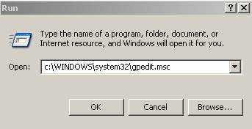

Return to the Table of Contents

Step 3: Traverse down the menu tree as follows:

Local Computer Policy ->

Computer Configuration->

Administrative Templates ->

Windows Components ->

Internet Explorer ->

Internet Control Panel ->

Security Page ->

Local Machine Zone
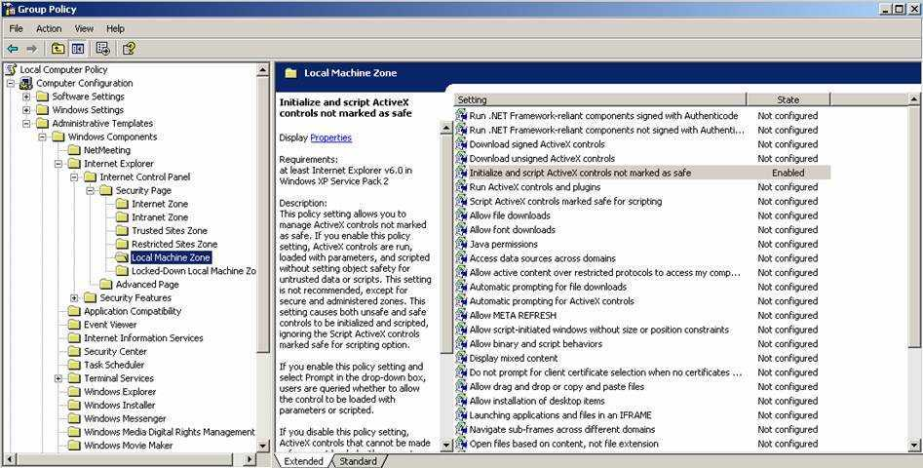

Note:In the pastyou could get to this setting from within IE, however,Microsoft now hides this particular zone, and you are not able to see it from withinIE / Tools / Internet Options – you have to access it from the Group Policy application

Return to the Table of Contents
Step 4:Double click on the setting: Initialize and Script ActiveX controls not marked as safe
Step 5:Change the value to Enabled, and then change the Drop down value to Enable

Step 6:Select the Apply button

Step 7:Select the OK button

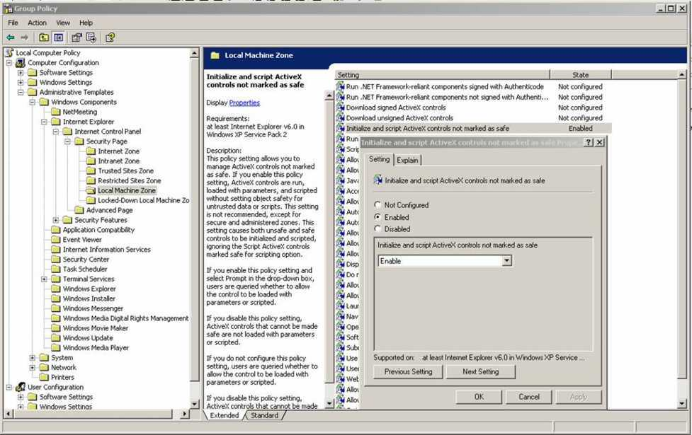

Step 8:The display should now show that this setting is enabled

Step 9:Close the Group Policy Edit application by selecting the Windows Close "X" in the upper right hand corner
Return to the Table of Contents

How to turn off the Reminders Pop Window

To turn off the Reminders Pop-up window please follow the following;

Step 1:Open an Encounter
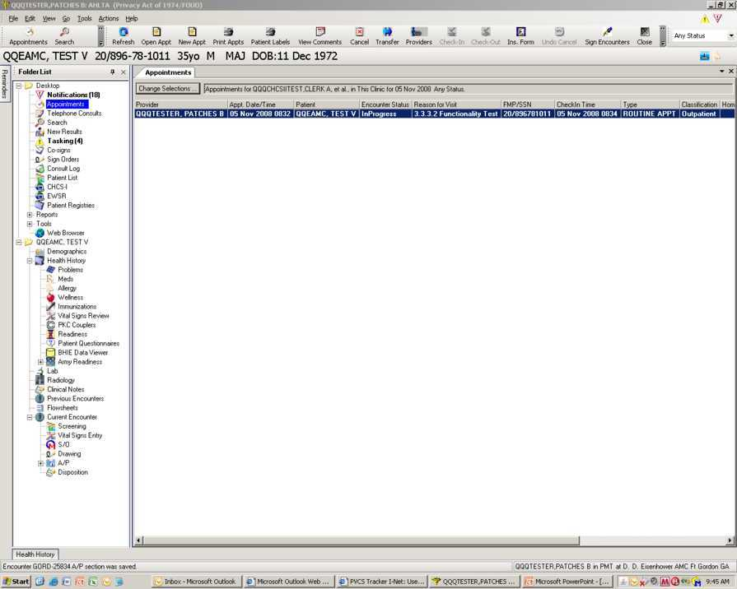

Return to the Table of Contents

Step 2:The Reminders window appears

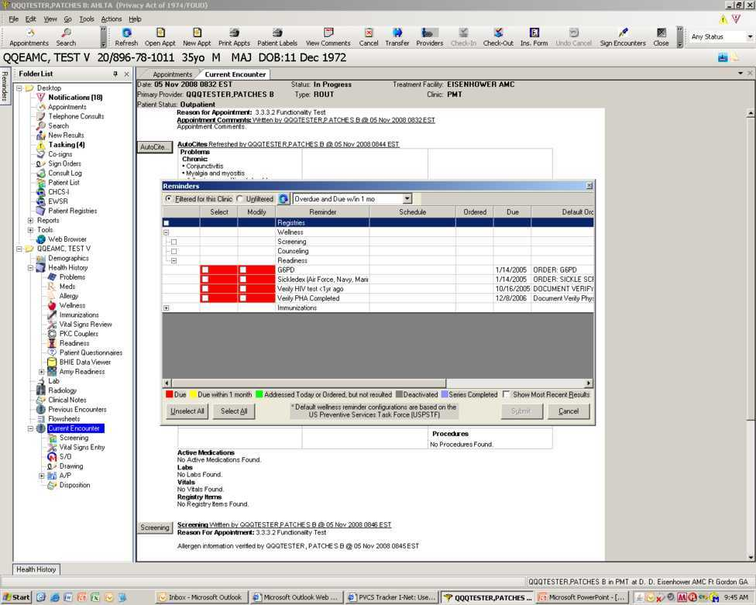

Return to the Table of Contents

Step 3:Place cursor on a line and right-click

Step 4:Select Properties

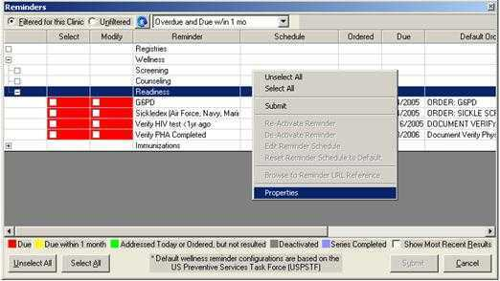

Return to the Table of Contents

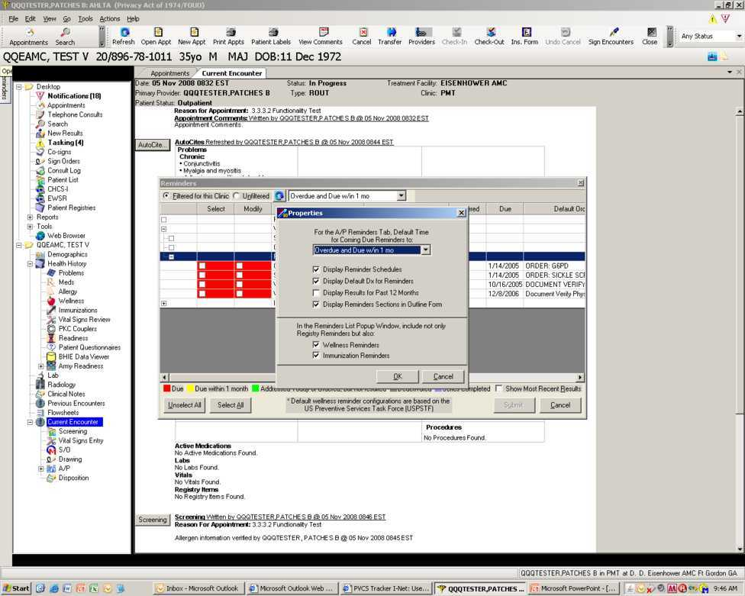

Step 5:Unclick the Wellness and Immunization Reminders
Return to the Table of Contents

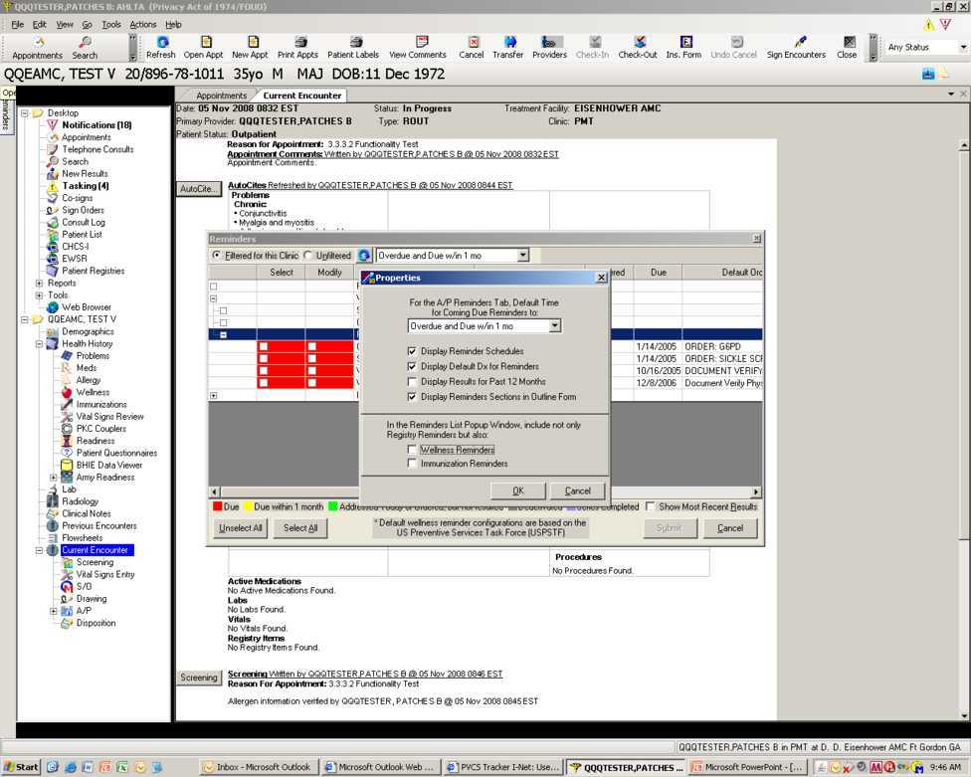

The Reminders List Popup Windowis now turned OFF.
Note:The Reminders List Popup Windowwill not appear when opening an encounterUnless the patient is assigned to a Registry.

Return to the Table of Contents
To turn onReminders List Popup Window

Step 1:Open an appointment, A/P andthen theReminders tab

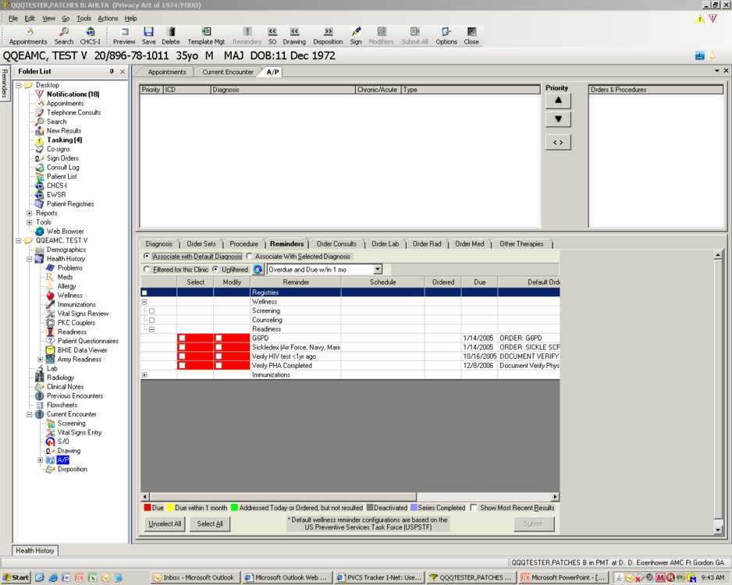

Return to the Table of Contents

Step 2:Place cursor on a line and right-click

Step 3:Select Properties

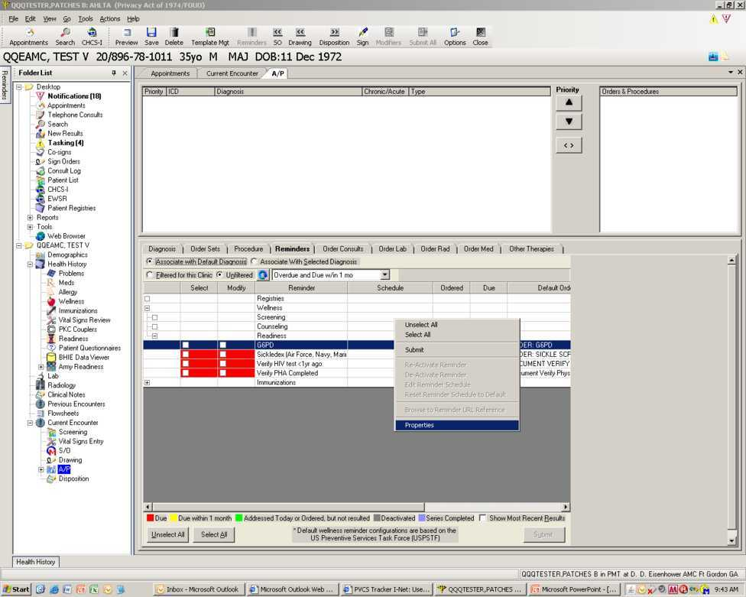

Return to the Table of Contents
Step 4:Click the Wellness and Immunization Reminders.

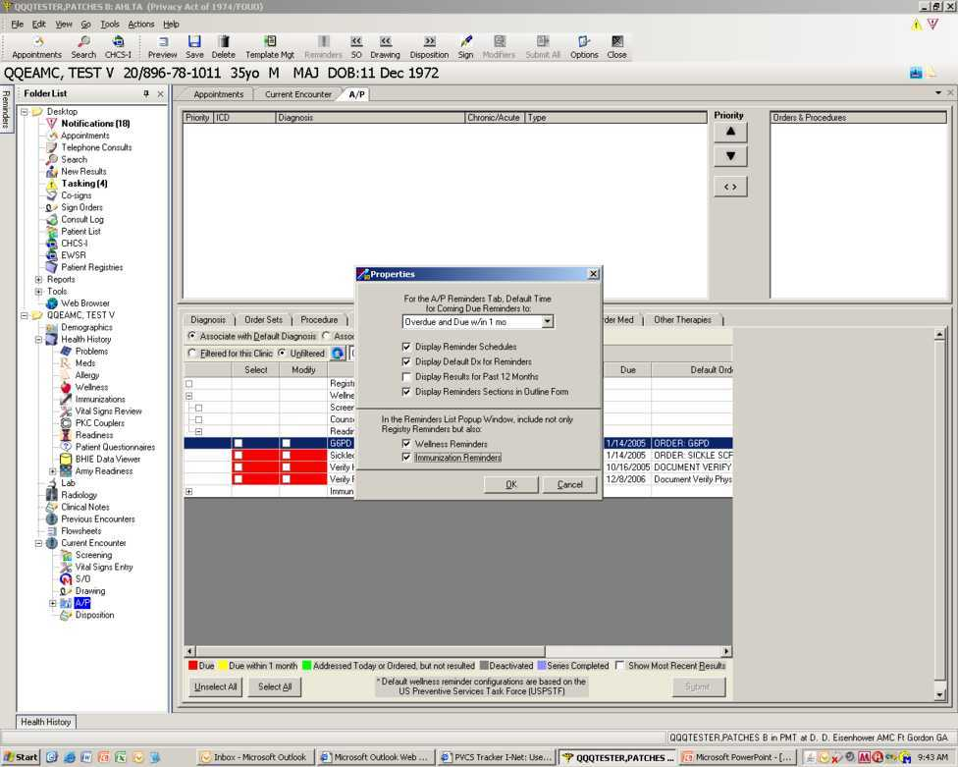

The Reminders List Popup Windowis now turned on. Reversing these steps will turn it off again.

Return to the Table of Contents

How to Uninstall/Install AHLTA with CTS

PLEASE NOTE:This section is for System Administrators ONLY!

There are two separate steps to installing AHLTA with the CTS.Please follow Process 1 of uninstalling the Microsoft Core XML Services (MSXML) 6.0. If this does not work then Process 2 will have to be attempted.

Prepared with steps fromMS Mallory Klemm, NH Camp Lejeune and Mary Gutierrez, Goodfellow AFB

Process 1:Follow Steps 3 thru 5 then skip to Step 22 to completion.

Process 2:Follow Steps 1 and 2 then skip to Steps 4 to completion.

NOTE:If the user has modified the customdict1.dic or autocorrect.act files, thenthese need to be offloaded from the workstation and reloaded onto the workstation after the reinstall.

These files are located in the “C:\Program Files\CH2CW\Data\RTData” folder.

Return to the Table of Contents
Step 1:Open the Control Panel Add/Remove programs

Step 2:Locate AHLTA and select Remove AHLTA

Note:Older versions are labeled CHCSII

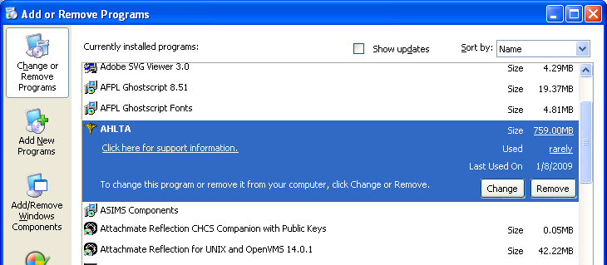

Return to the Table of Contents

Process 1

Step 3:Remove the MSXML6 by downloading and installing theWindows Installer Cleanup Utility

Step 4:Launch the utility (Start > All Programs > Windows Install Clean Up), find MSXML6 SP2 in the list, select it, and click remove.

Step 5:Reboot

Process 2

Step 6:Locate theHKEY_LOCAL-MACHINE\SOFTWARE\Microsoft\Microsoft SQL Server\MSSQL.x\Setuplocation

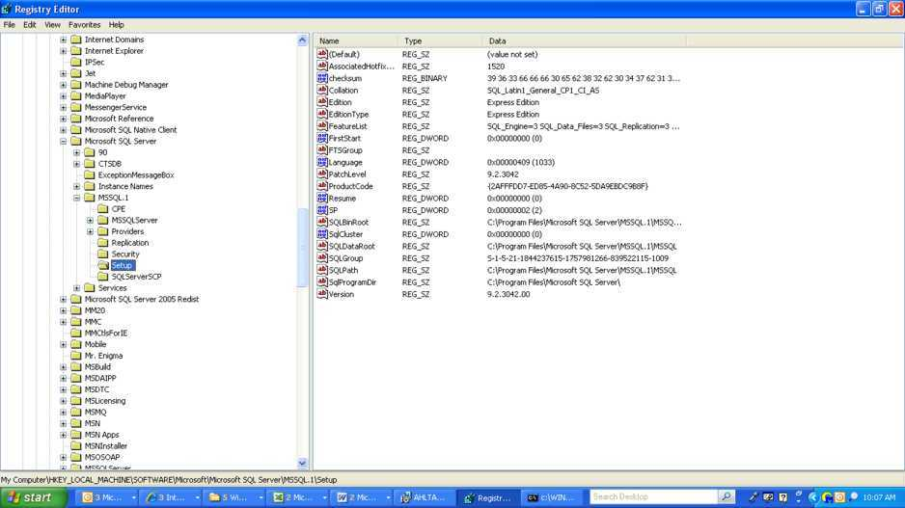

Return to the Table of Contents

Step 7:Find the following Keys and remove them: SQLGroup, FTSGroup, andAGTGroup

Note:AGTGroup key is usually not present.

Step 8:Locate the Microsoft SQL Server 2005 and select Change

Note:EUDs may vary depending on prior version installed. There could also be an old CTS version that will need to be uninstalled.

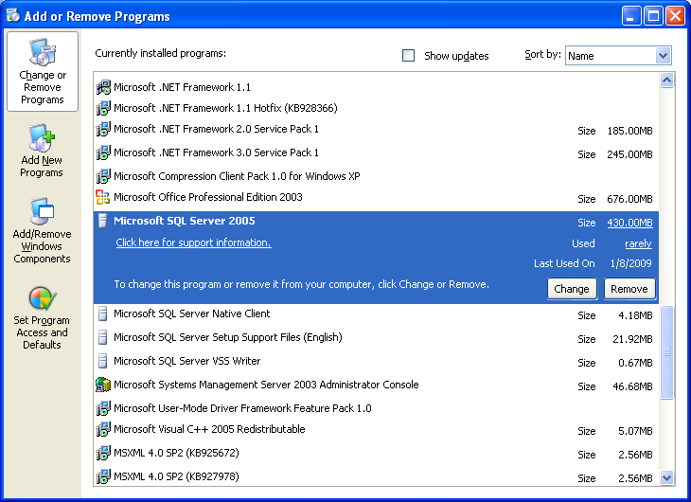

Return to the Table of Contents
Step 9:Select “SQL Server 2005 common components: Workstation Components”

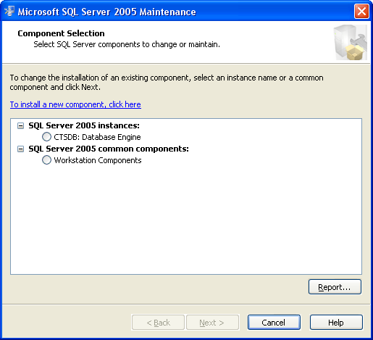

Return to the Table of Contents
Step 10:Select Next

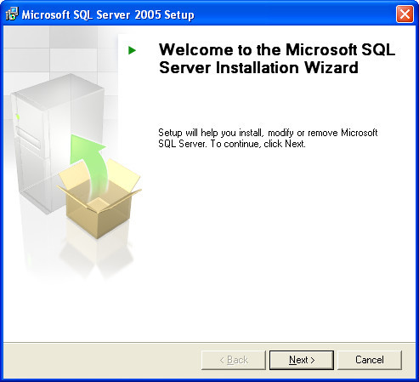

Return to the Table of Contents
Step 11:Select Next

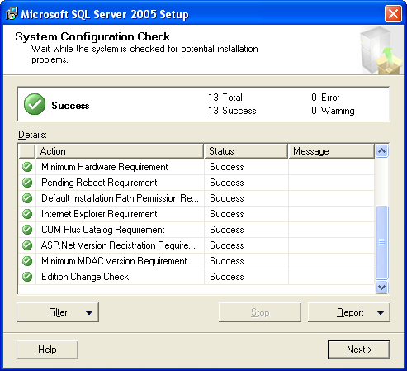

Return to the Table of Contents
Step 12:Select “Change Installed Components”

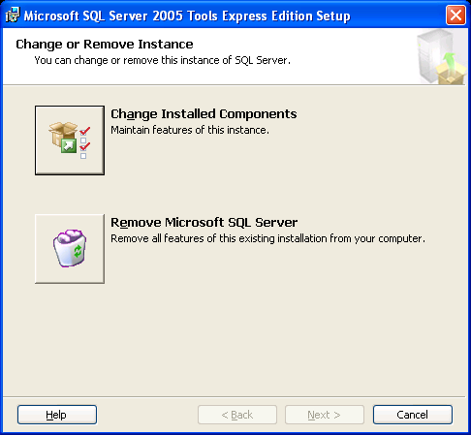
Return to the Table of Contents
Step 13:Click “+” next to “Client Components”

Step 14:Click “Connectivity Components”

Step 15:Select “Entire Feature will be installed on local hard drive”

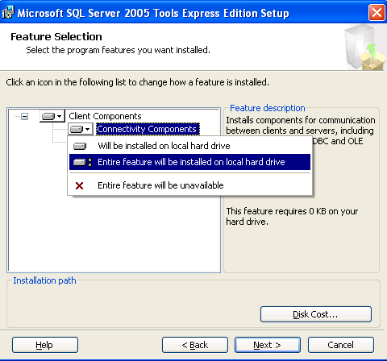

Return to the Table of Contents
Step 16:Click “Software Development Kit”

Step 17:Select “Entire Feature will be installed on local hard drive”

Step 18:Click Next

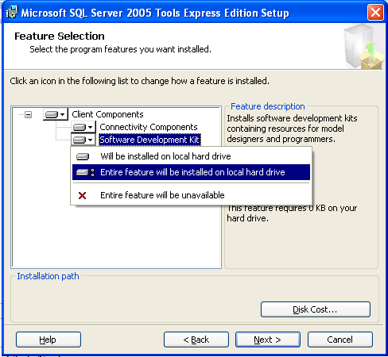

Return to the Table of Contents
Step 19:Select “Next”

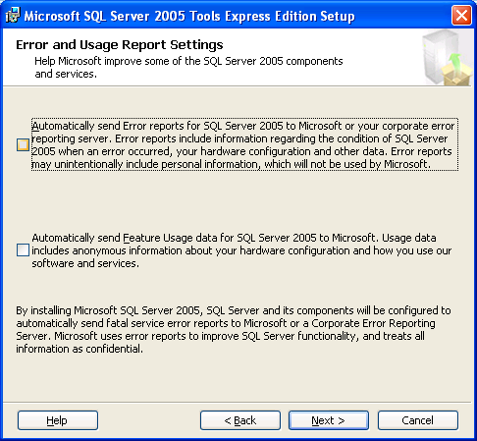

Return to the Table of Contents
Step 20:Select “Install”

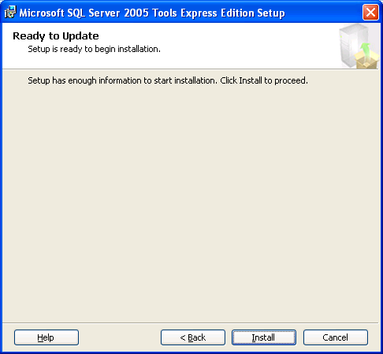

Note:If you get the same errors after following these steps whenyouinstall AHLTA and CTS, repeat the second step. Instead of selecting “SQL Server 2005 common components: Workstation Components”, select “SQL Server 2005 instances: CTSDB: Database Engine” and follow directions.

Return to the Table of Contents
Step 21:After the uninstall iscomplete, delete all folders left under C:\Program Files\Microsoft SQL Server

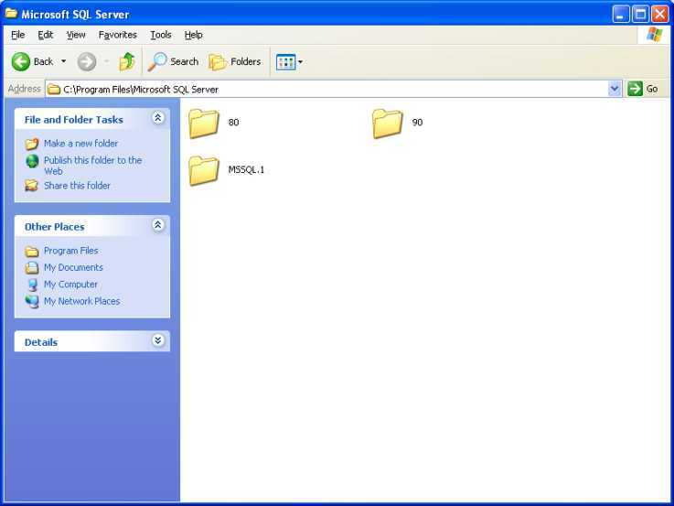

Step 22:Right click on Start\Run and type in regedit

Return to the Table of Contents
Step 23:Reboot the EUD

Step 24:Once the EUD is back on run a Registry Cleaner program

Note:Do this prior to reinstalling AHLTA (SAIC uses Attatech COM Registry Cleaner and can supply it on request)

Step 25:Reboot theEUD

Step 26:This step assumes that you have the location of the AHLTA version needing to be installedunder the AHLTA folder.Locate the setup.exe and double-click to begin the install process:Select Next.

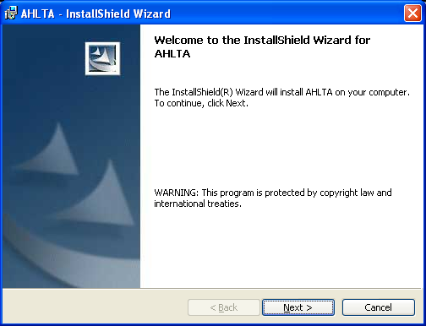

Return to the Table of Contents
Step 27:Select which option you require.

Note:These instructions are for installing AHLTA with the CTS

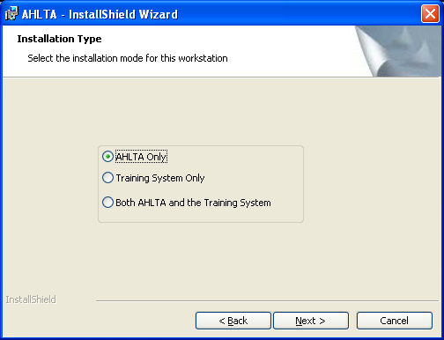

Return to the Table of Contents
Step 28:Inputfollowing information into install screen. Select Next.

Note:This information is Site specific so please check with the Site Admins for the data

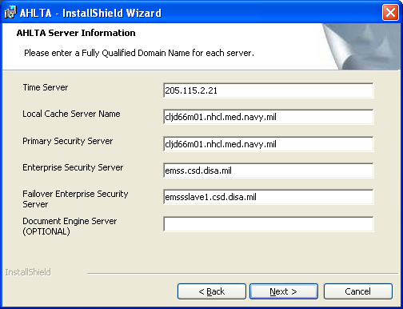

Return to the Table of Contents
Step 29:Input the Primary Update path as shown below then Select Next.

Note:The above should be left blank if the Site does not use the Auto-Update feature

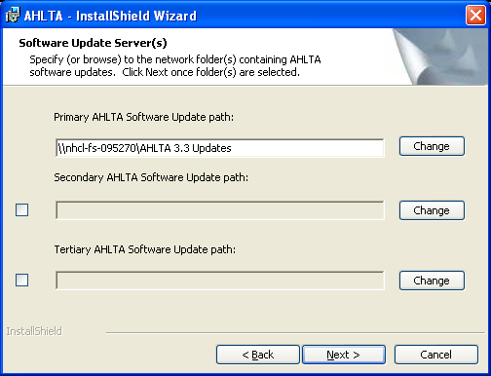

Return to the Table of Contents
Step 30:Select Next.

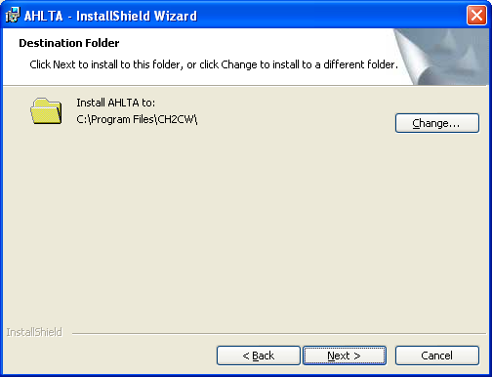

Return to the Table of Contents
Step 31:Select Next

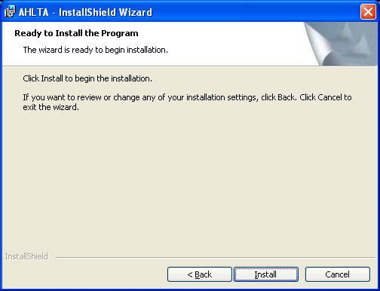

Return to the Table of Contents
Note:You will see several screens before the installation is complete.

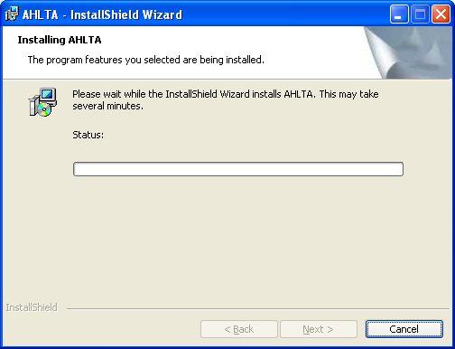

Return to the Table of Contents
Step 32:Select Finish.

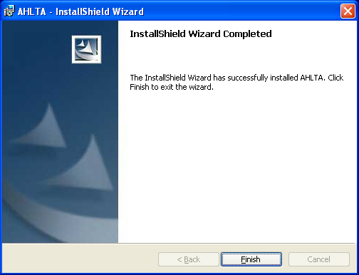

Return to the Table of Contents
Step 33:Select Yes to reboot PC.

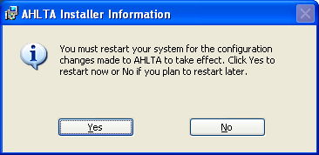

Note:After the EUD starts up you will need to reinstall MSXML6 and install the latest ICD 9 Codes (this guide assumes you have the latestICD 9 Codes to install.)

Step 34:If the SQL Server installs successfully (from CTS,) then reinstallMSXML6.

Note:This may fail depending on which version of SQL Server you installed, and which components. In either case, obtain the critical update from KB #954459, which you can get inSecurity Bulletin MS08-069. Just search for your operating system and the download for "Microsoft XML Core Services 6.0.“Run this installer and you should be all up to date as far as MSXML6 goes.

Return to the Table of Contents
Step 35:On the System Tray, click on the Medcin Icon (Looks like an M with half moon)

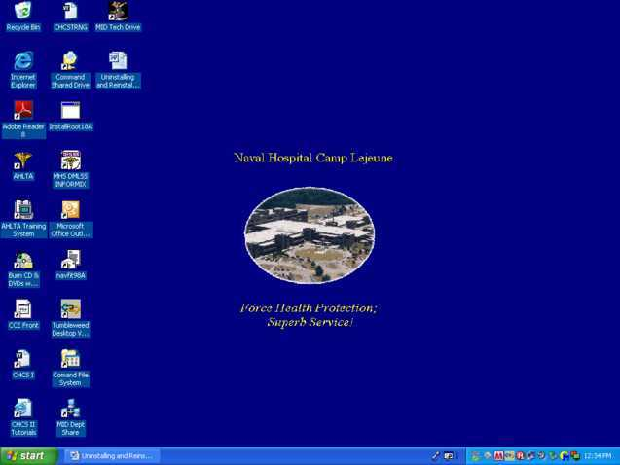

Return to the Table of Contents
Step 36:Select Shutdown on screen.

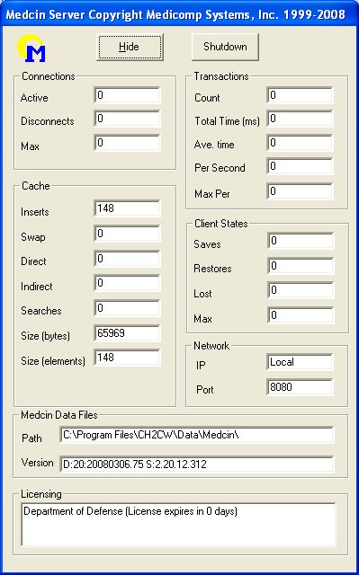

Return to the Table of Contents
Step 37:Select Yes to quit.

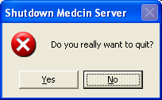

Step 38:Locate and double-click the ICD 9 Codes to start the install process

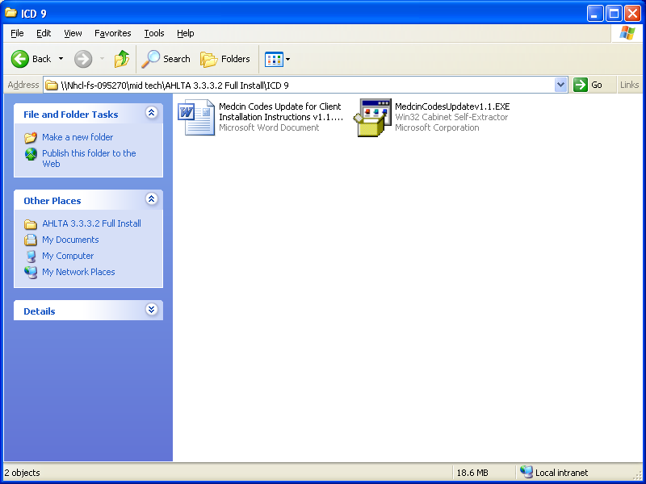
Return to the Table of Contents
Note:The following screen will run.

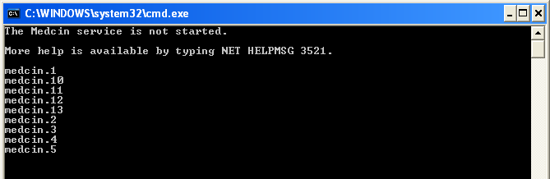

Step 39:Update Complete, Select OK

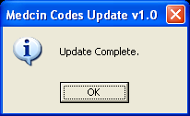
Step 40:Give the user Full Control over to the CH2CW folder and sub-folders.

Note:At a minimum, users must have read/write/modifyrightsto this folder(s);however,it is recommendedthat users havefull control

a.Navigate to C:\Program Files\CH2CW folder

b.Right click on the CH2CW folder/properties/security tab.

c.Select user and then make sure Full Control rights are checked.

d.Click Apply.

These rights will propagate down to the subfolders and files when AHLTA is installed.

Step 41:Test AHLTA

Return to the Table of Contents

Ideal Options andAuto-Cite Settings
- Appointment/Telcon Module: Me, All My Clinics and Today plus Incomplete

  - Appointments - Providers – Me, Specific Clinics, Today Only
  - Telcons – Providers – Me, All My Clinics and Today plus Incomplete
  - Appointments/Telcons – Clerks – All Providers, Specific Clinics, Today Only
  - Appointments/Telcons - Head Nurses, Techs, etc. – Me, All My Clinics and Today plus Incomplete
  - Appointments/Telcons – Nurses assisting providers – Provider, Specific Clinic, Today Only
  - Use as Default settings - If need to look at other things then change settings on a temporary basis
- Auto-Cites: Labs/Meds/Rads for the past six months and Problems
- Heath History: Set as desired, with 3.3.3.x this is now asynchronous
- Labs/Meds/Rads Module:
  - With 838 “Last 10”
  - With 3.3.x “Last 20”
- Previous Encounters:
  - With 838 “Last Four” is the default
    - Using View All may cause performance issues or not allow the user be able to see the Previous Encounters for the Patient
  - With 3.3.x “Last 20” is the default
- Uncheck the auto-save box

High/Heavy: Any setting that asks for “all data” or for “all time frames” will take time to retrieve especially forpatients with some history.

Return to the Table of Contents

Resources
- Note that manyWEB Sitesfrequently used have links to 3.3 resources that are actually older 838 resources. The user manual and QRGs also have several outdated references.
- AHLTA Blog by Dr. Inae -http://www.ahlta.blogspot.com/
- AHLTA RX (found atNavalHospitalCamp Pendleton):This periodic newsletter offers answers to common questions, new workarounds and additional resources.
- AMEDD VMC site:https://vmc.amedd.army.mil- There is a discussion forum on this site specific to 838 to 3.3 issues
- NavyAHLTA:www.navyahlta.com. This is based on 3.3 functionality.
- USAFPwebsite(click the link for 3.3):http://www.usafp.org/AHLTA-Information-FAQs.html

Return to the Table of Contents

Security Risk Assessment
Introduction:
The Microsoft patches referenced are changing a key ActiveX Policy setting within the OS that causes repeated dialog boxes and error messages to be displayed to the user. Recommended mitigation: Change the ActiveX Policy setting on client machines running the XP operating system to “Enable” on the “Initialize and script ActiveX controls not marked as safe” control.

This control is located in the “Security Zone: Local Machine” which affects ActiveX controls located on Hard Drives. This change does not affect the other Security Zones. When browsing the web or Intranet, the “Initialize and script ActiveX controls not marked as safe” are still set to block ActiveX. The Local Machine Zone change only allows ActiveX controls to run that are on thecomputer’shard drive where AHLTA resides. (C:\Program Files\CH2CW\BIN)

Risk Assessment:
About security zones
The Internet Explorer user interface lets you configure four security zones. AHLTA settings are as follows:
- Internet
- Local intranet
- Trusted sites
- Restricted sites
Navigation is blocked to the Local Machine at each of these higher levels.

A fifth zone, the Local Machine zone, is an implicit zone that exists on your local computer. You cannot configure the security settings for this zone in Internet Explorer. You also cannot configure the security settings by using the Internet Options Control Panel. However, if you have administrator permissions, you can configure the security settings for the Local Machine zone by changing a registry setting.
Internet Explorer lets you assign a Web site to a security zone.
A Web site that is in the Internet zone has a higher level of security than a Web site that is in the Trusted sites zone or that is in the Local intranet zone.
By assigning a Web site to a security zone, you can control how a Web site performs operations on your computer.
For example, you can prevent a Web site from performing potentially unsafe operations on your computer by assigning the Web site to a security zone that has the most restrictive level of security.

Identified Risk
On an incorrectly configured machine, a dialog will appear in Internet Explorer with one of two messages.
- The current Internet site is trying to open a file that is on your “Trusted sites” list. If you trust this Internet site, proceed by clicking OKThe current site is in your Restricted sites list and is trying to open a file that is on the Intranet. We recommend that you do not allow this.
A user must explicitly allow the requested zone elevation.
On a correctly configured machine if a user clicks a link which causes the Web site to attempt to navigate to a higher zone, navigation is blocked for navigation to the Local Machine.

Mitigations in place
It would only be the Active X required by the Microsoft Operating System, and AHLTA that would be running.
Other software with ActiveX is not supposed to be on AHLTA Servers/workstations, such as MS Office, any email, etc.
Even if someone managed to download something with malicious code, they cannot install it, unless it is digitally signed.
Four other layers of protection sit above the Local Machine level.
Norton and most major Anti-virus software scan and protect against unfamiliar ActiveX code.
No ActiveX can be loaded externally because all ports and drives are disabled.
ActiveX cannot logon to AHLTA.

Summary
There is no requirement concerning this setting. This is not an issue when applying a DISA STIG. Decisions will be made by the Services or local sites. This information serves as added value to assure decision makers that this issue has been reviewed from a security perspective and using these instructions would not create a new security risk

Note: For the Air Force this will need to be set at INOSC level

Return to the Table of Contents

